Electricity Dataset Visualation

# School_2013_2014_KW.csv

Entire_Dataset_Plot.png

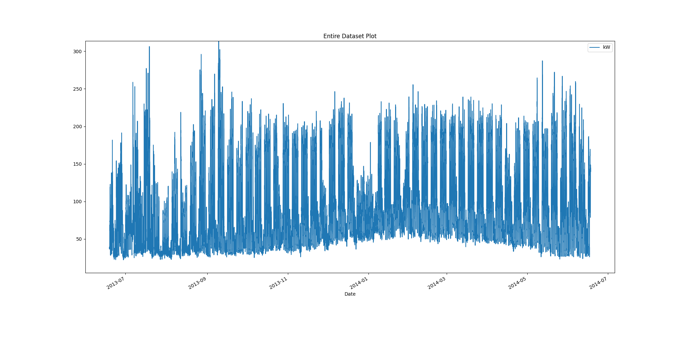

# Plot of month with max demand recorded

Month_maximum_recorded_demand.png

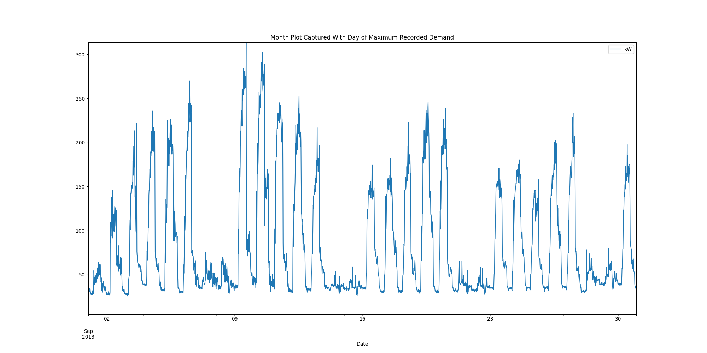

# Power box plots per month

AllDatakWboxPlots.png

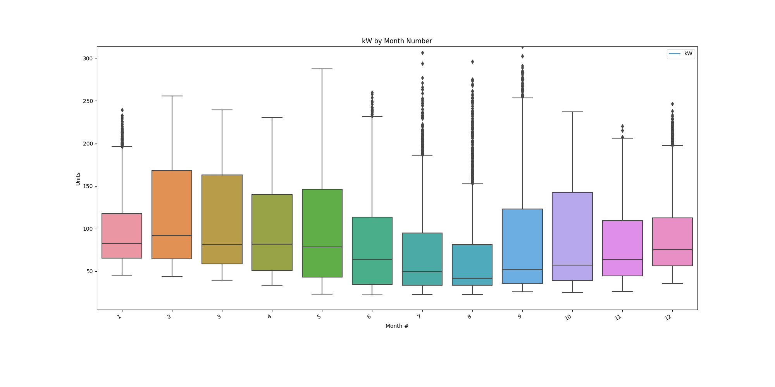

# Power consumption trends

kWtrendsPlot.png

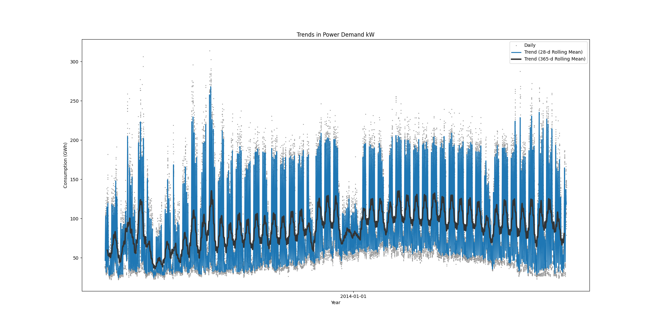

Data Analysis Report Winter

Winter Months Electrical Load Profiles

datasetPlot.png

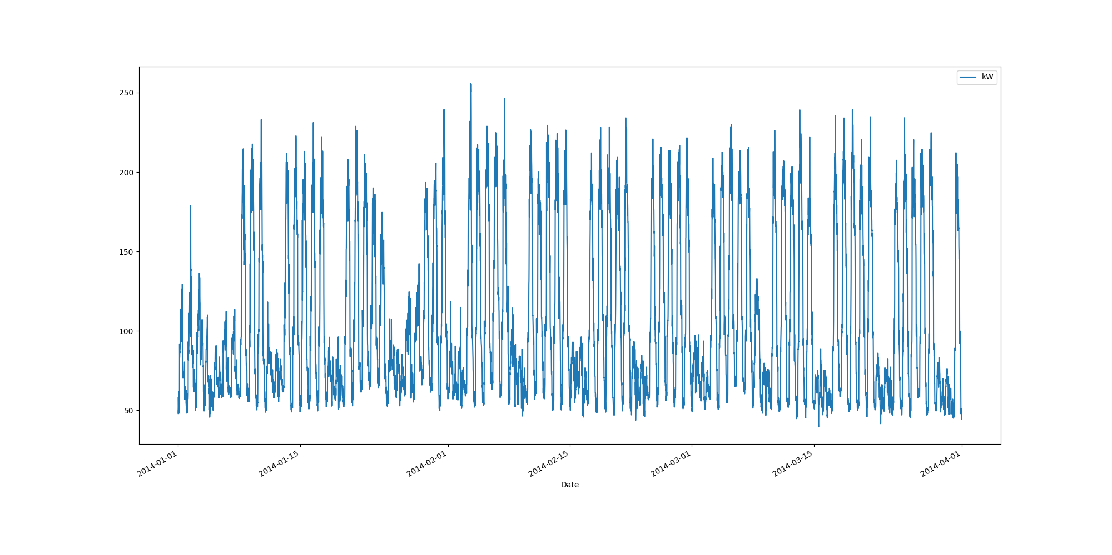

# Max Demand Found In Dataset

kW 255.6  
Name: 2014-02-03 14:45:00, dtype: float64

# Dataset Summary Statistics

kW  
count 8636.000000  
mean 105.233418  
std 51.635909  
min 39.600000  
25% 63.200000  
50% 85.500000  
75% 151.400000  
max 255.600000

# Highest Ranked Change Point Algorithm Detection

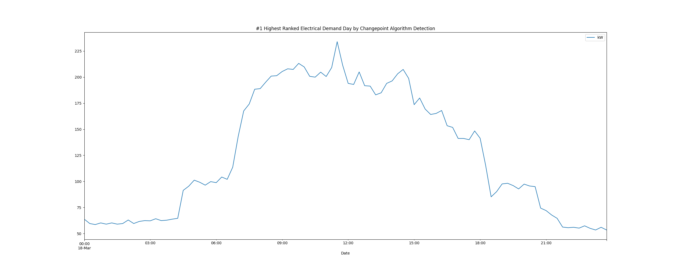

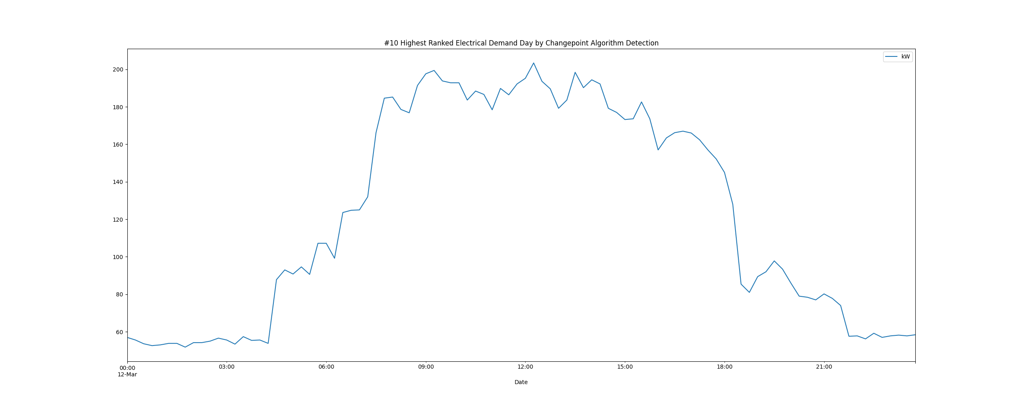

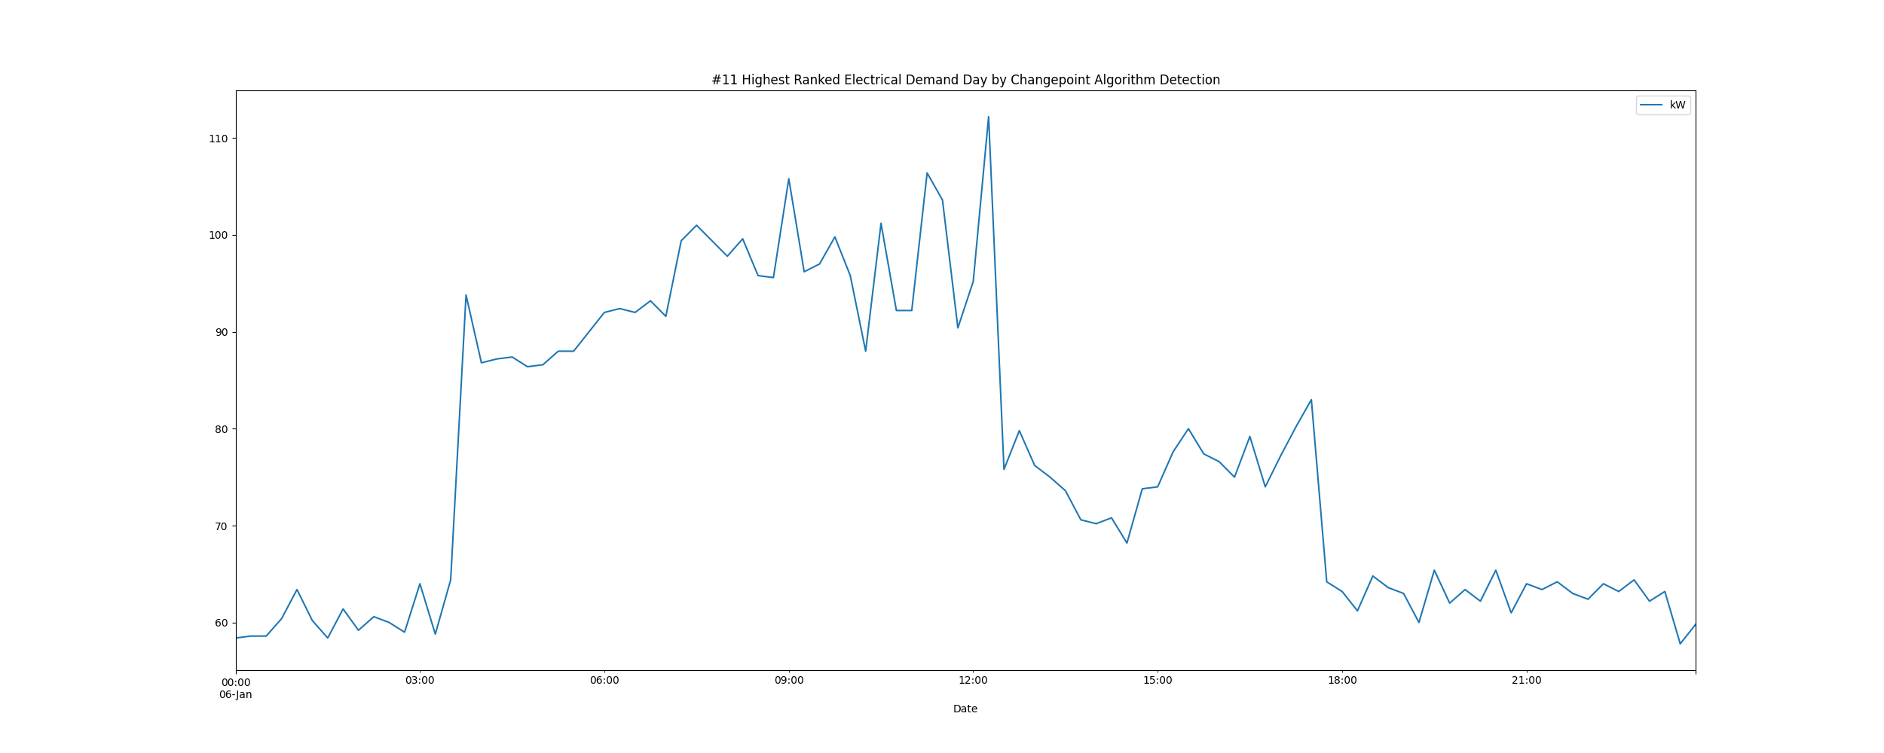

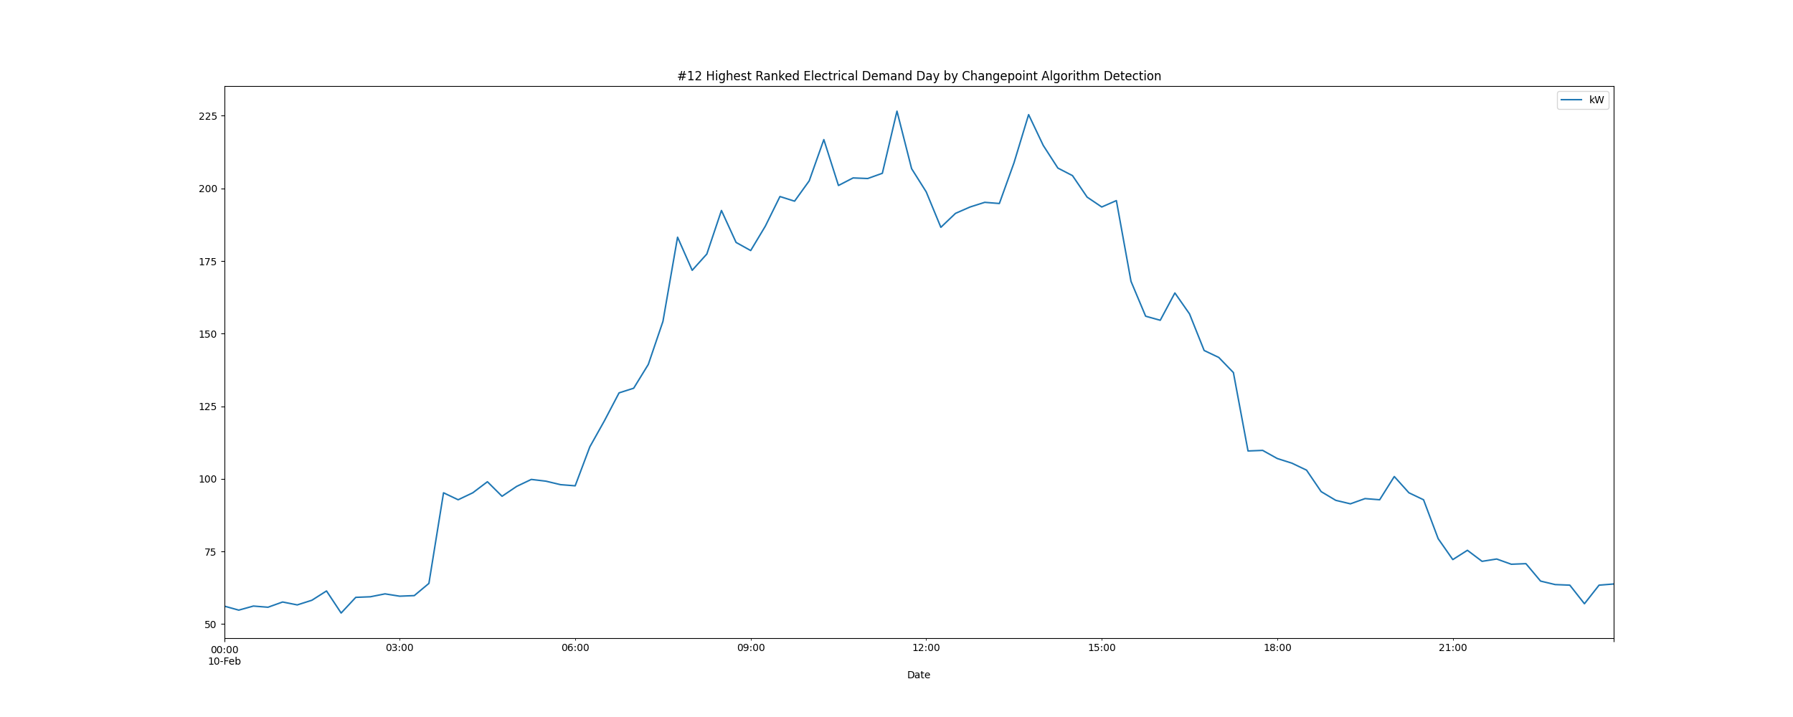

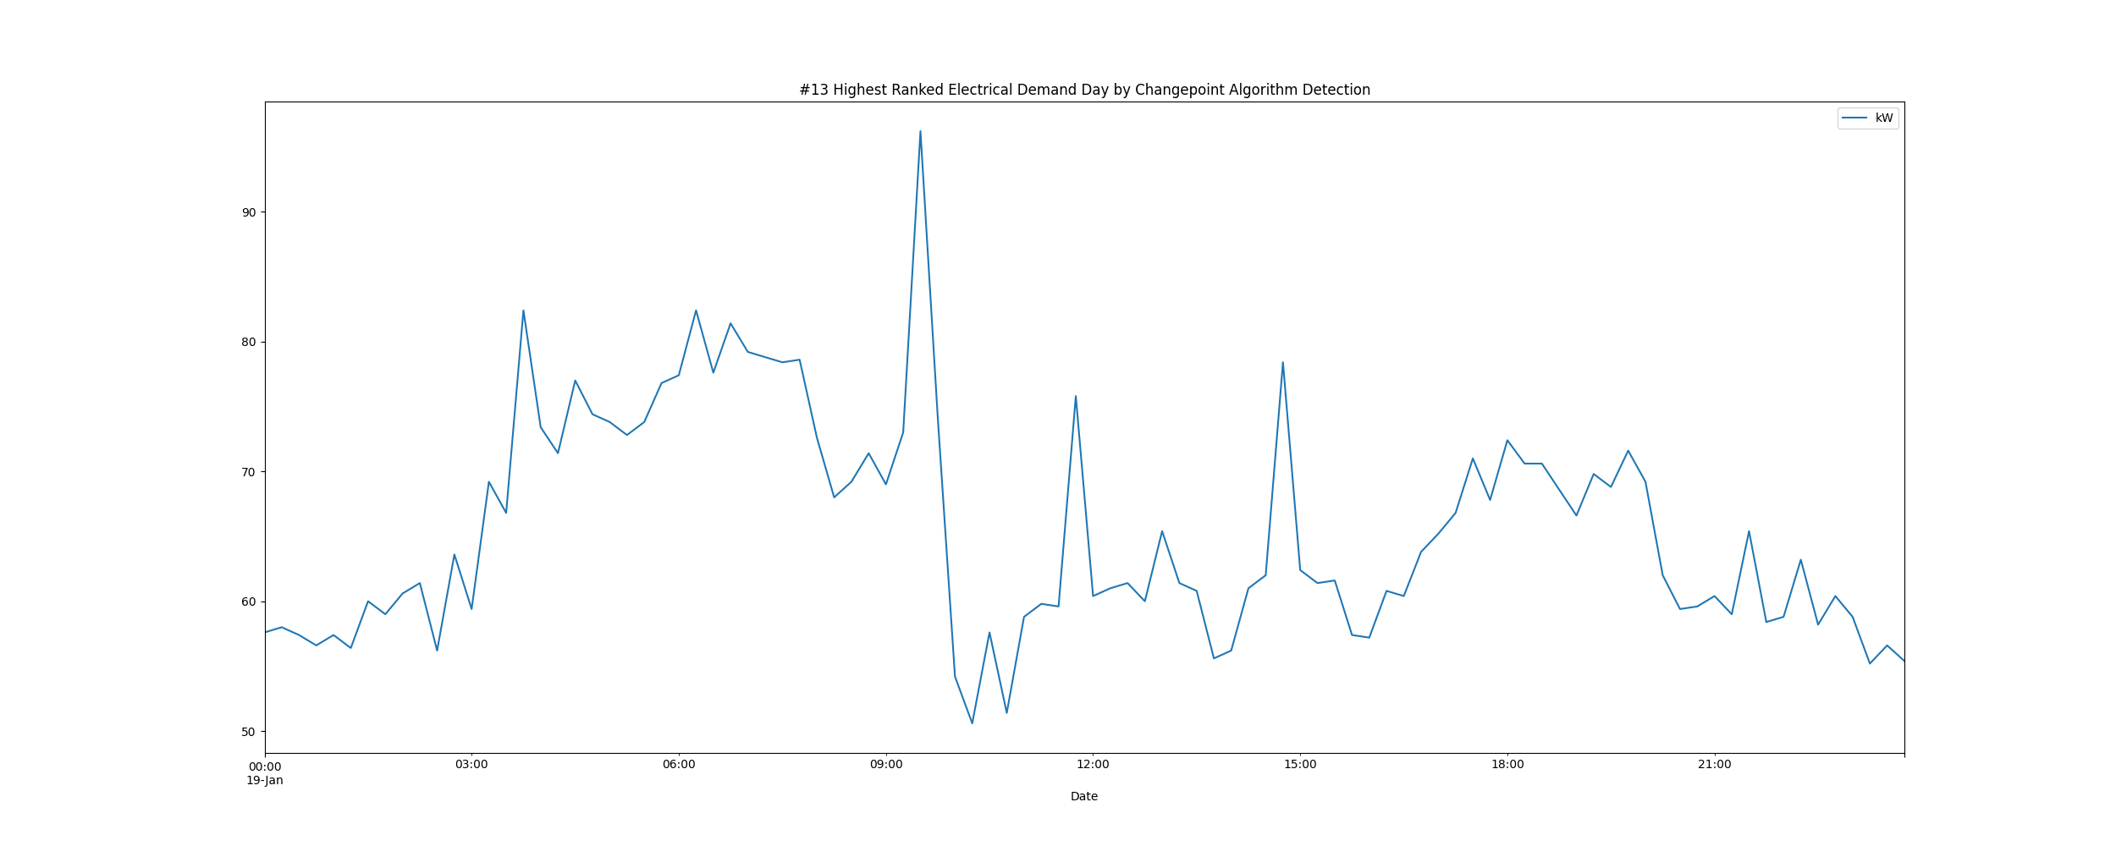

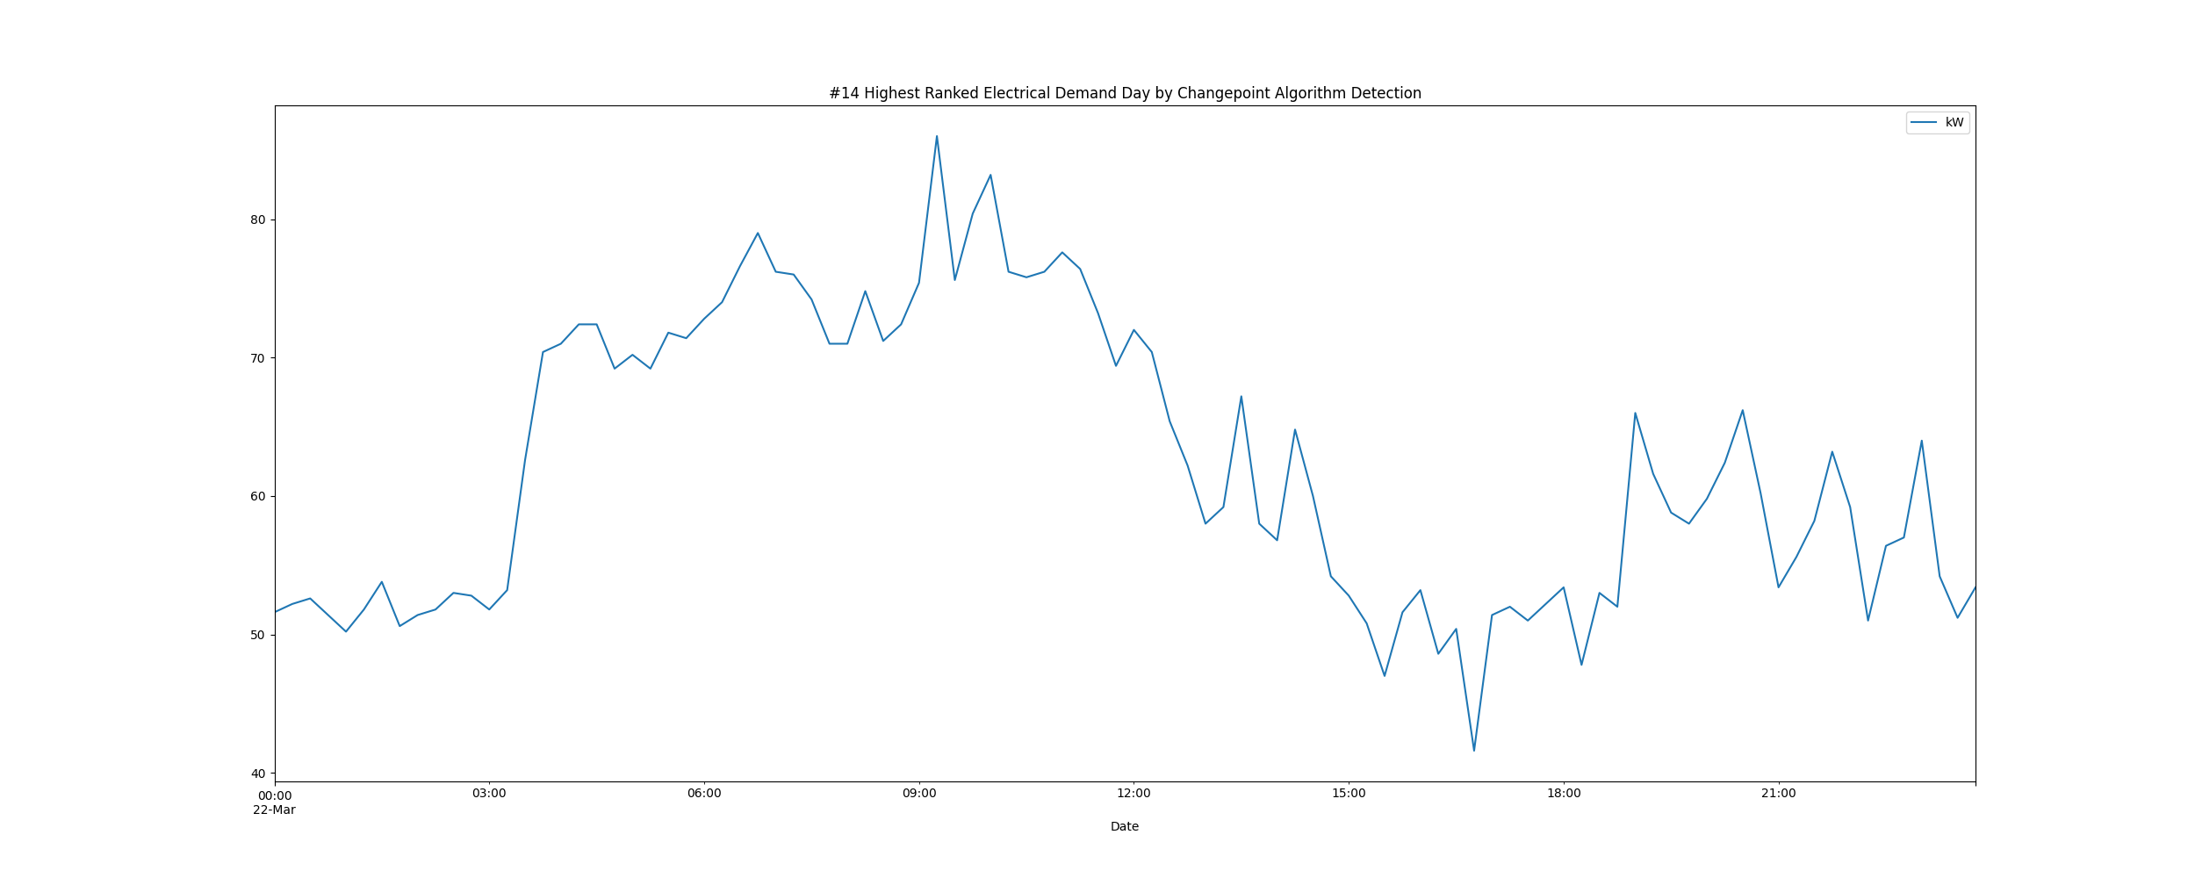

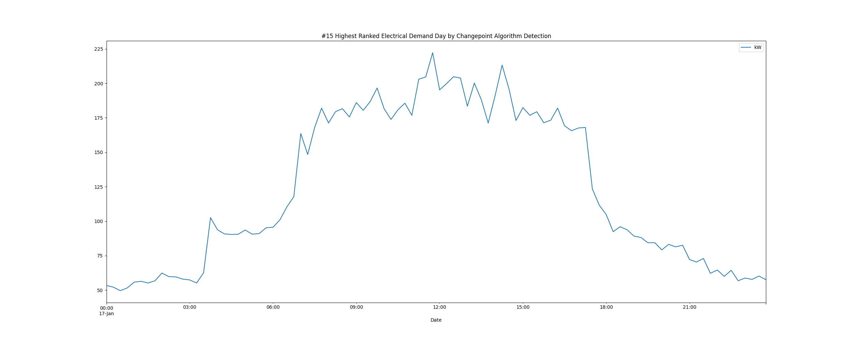

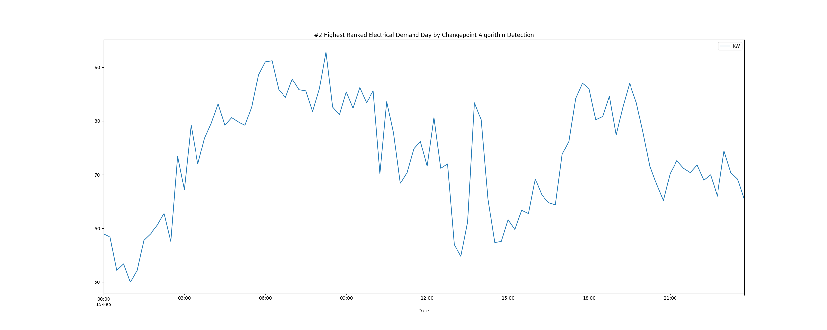

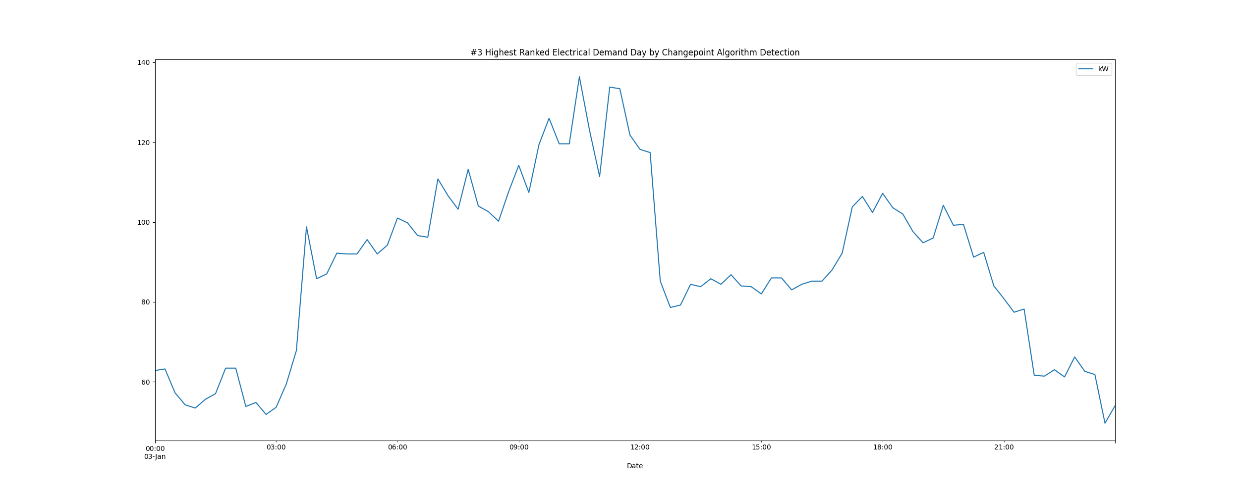

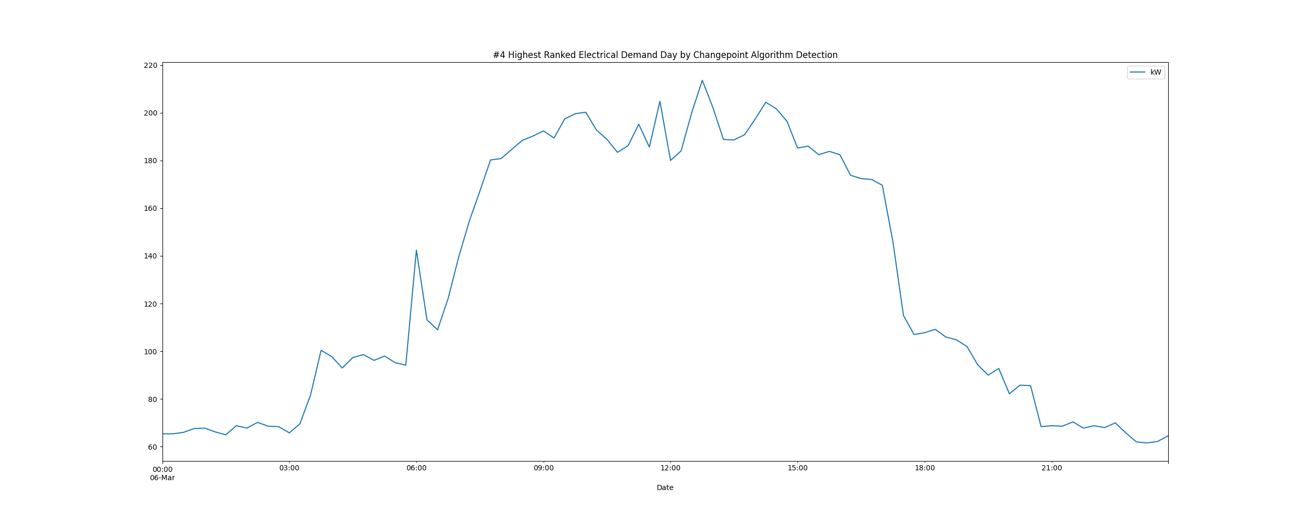

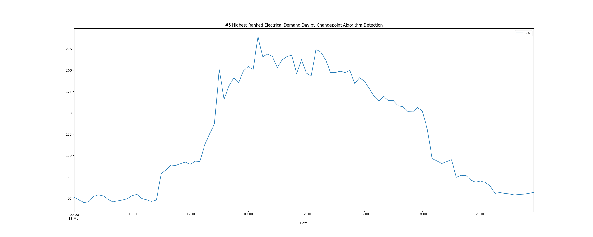

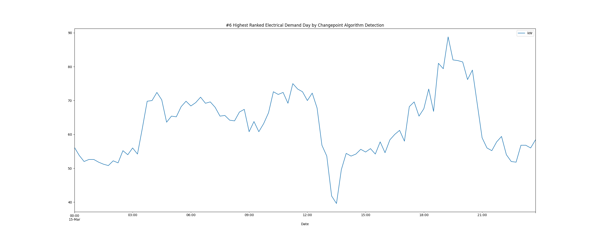

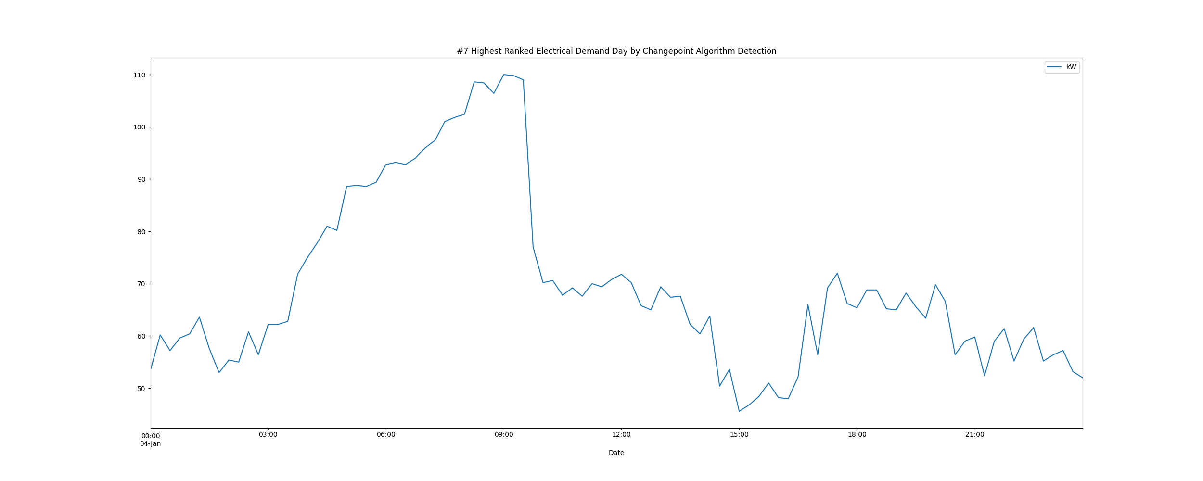

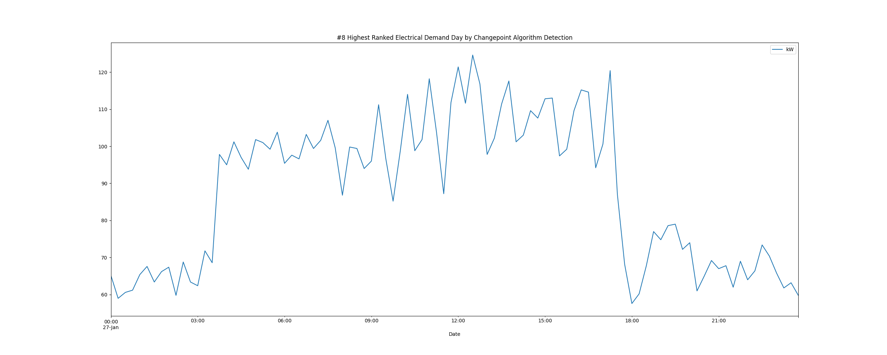

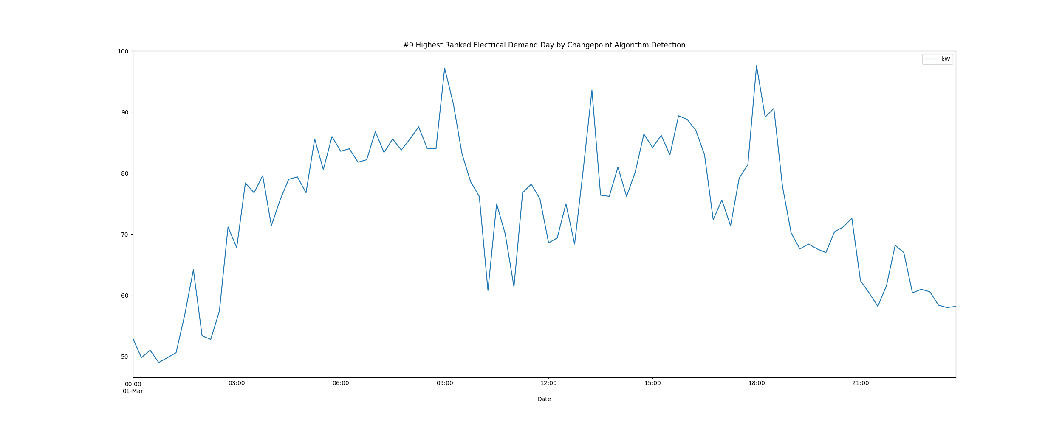

# Daily High and Low Load kW Values

highLowLoadsPlot.png

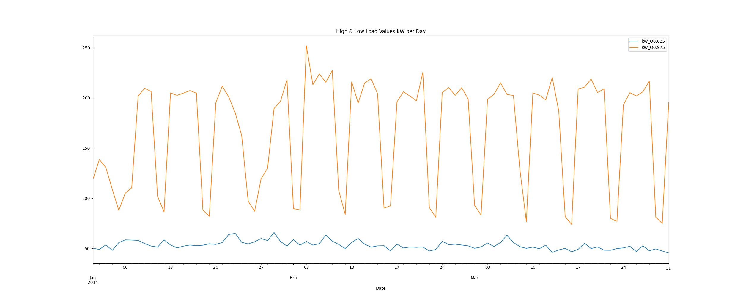

# Max Demand and Hour of Day Plot

Max_Demand_and_Max_Hour_of_Day.png

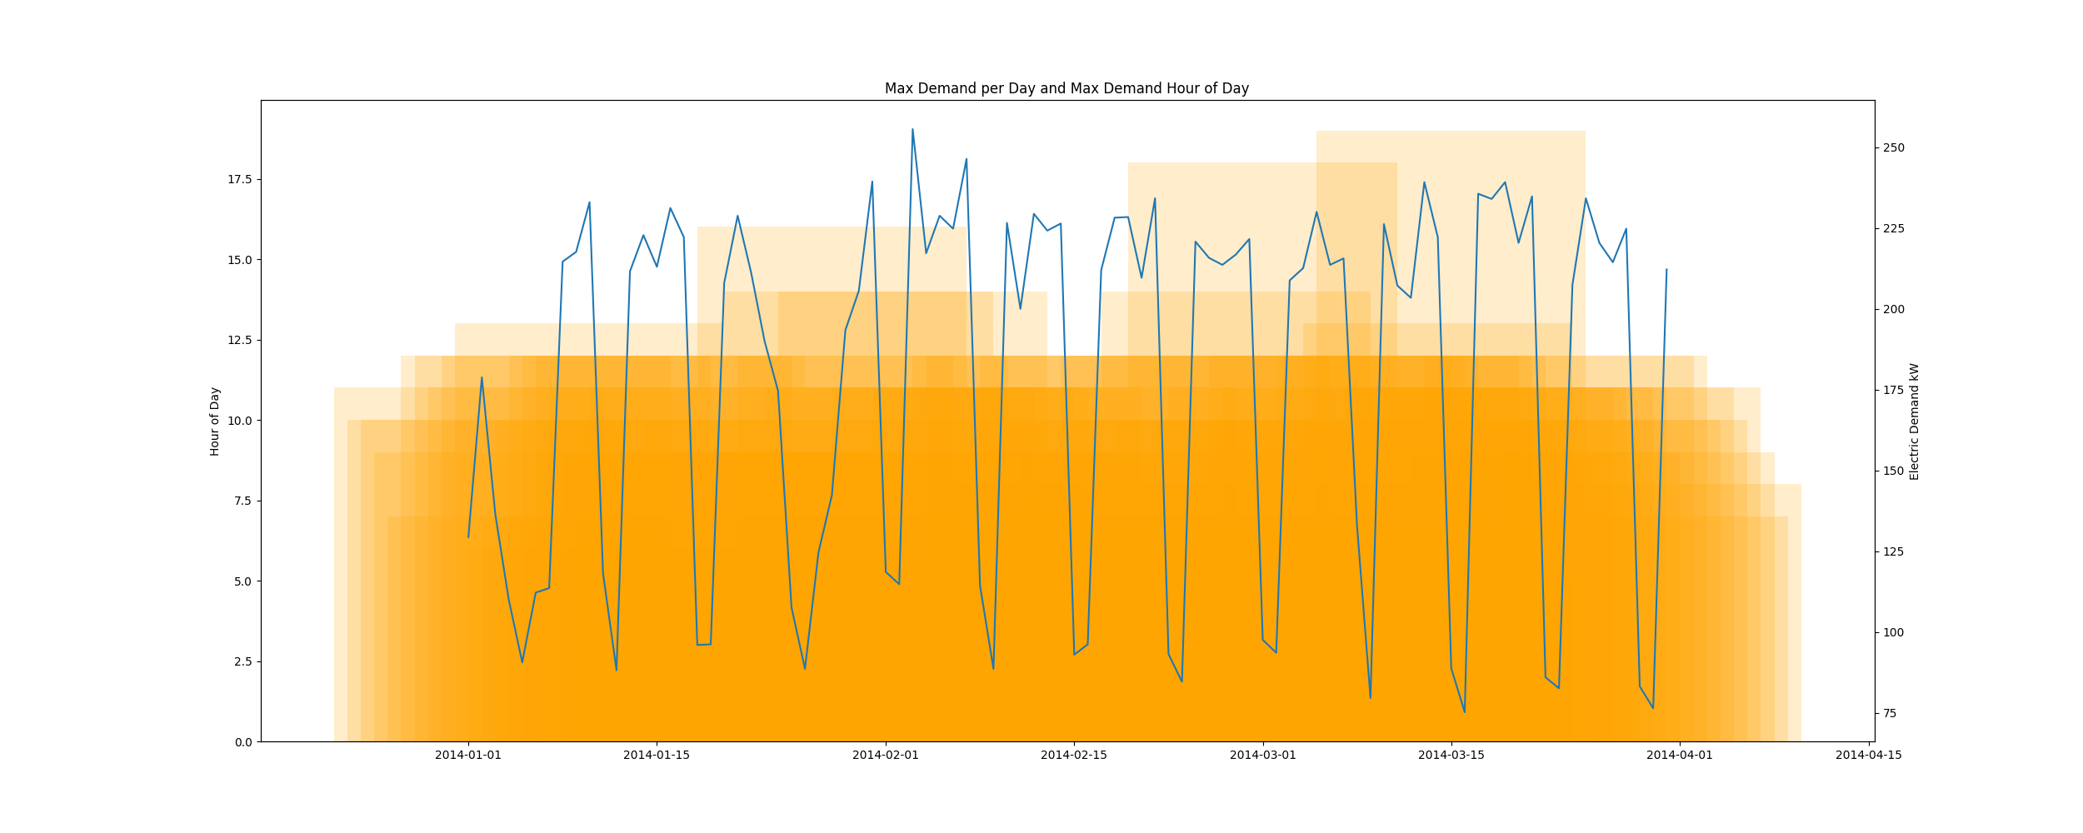

* Resampling the interval dataset to calculate units of energy KWh/day, the first day is 2014-01-01 and the last day is 2014-03-31
* Total days in dataset 89 days
* Total Sum of calculated electrical energy 227198.95 kWh

# kWh Rolling 7 Day Avg

kWhRollingAvg.png

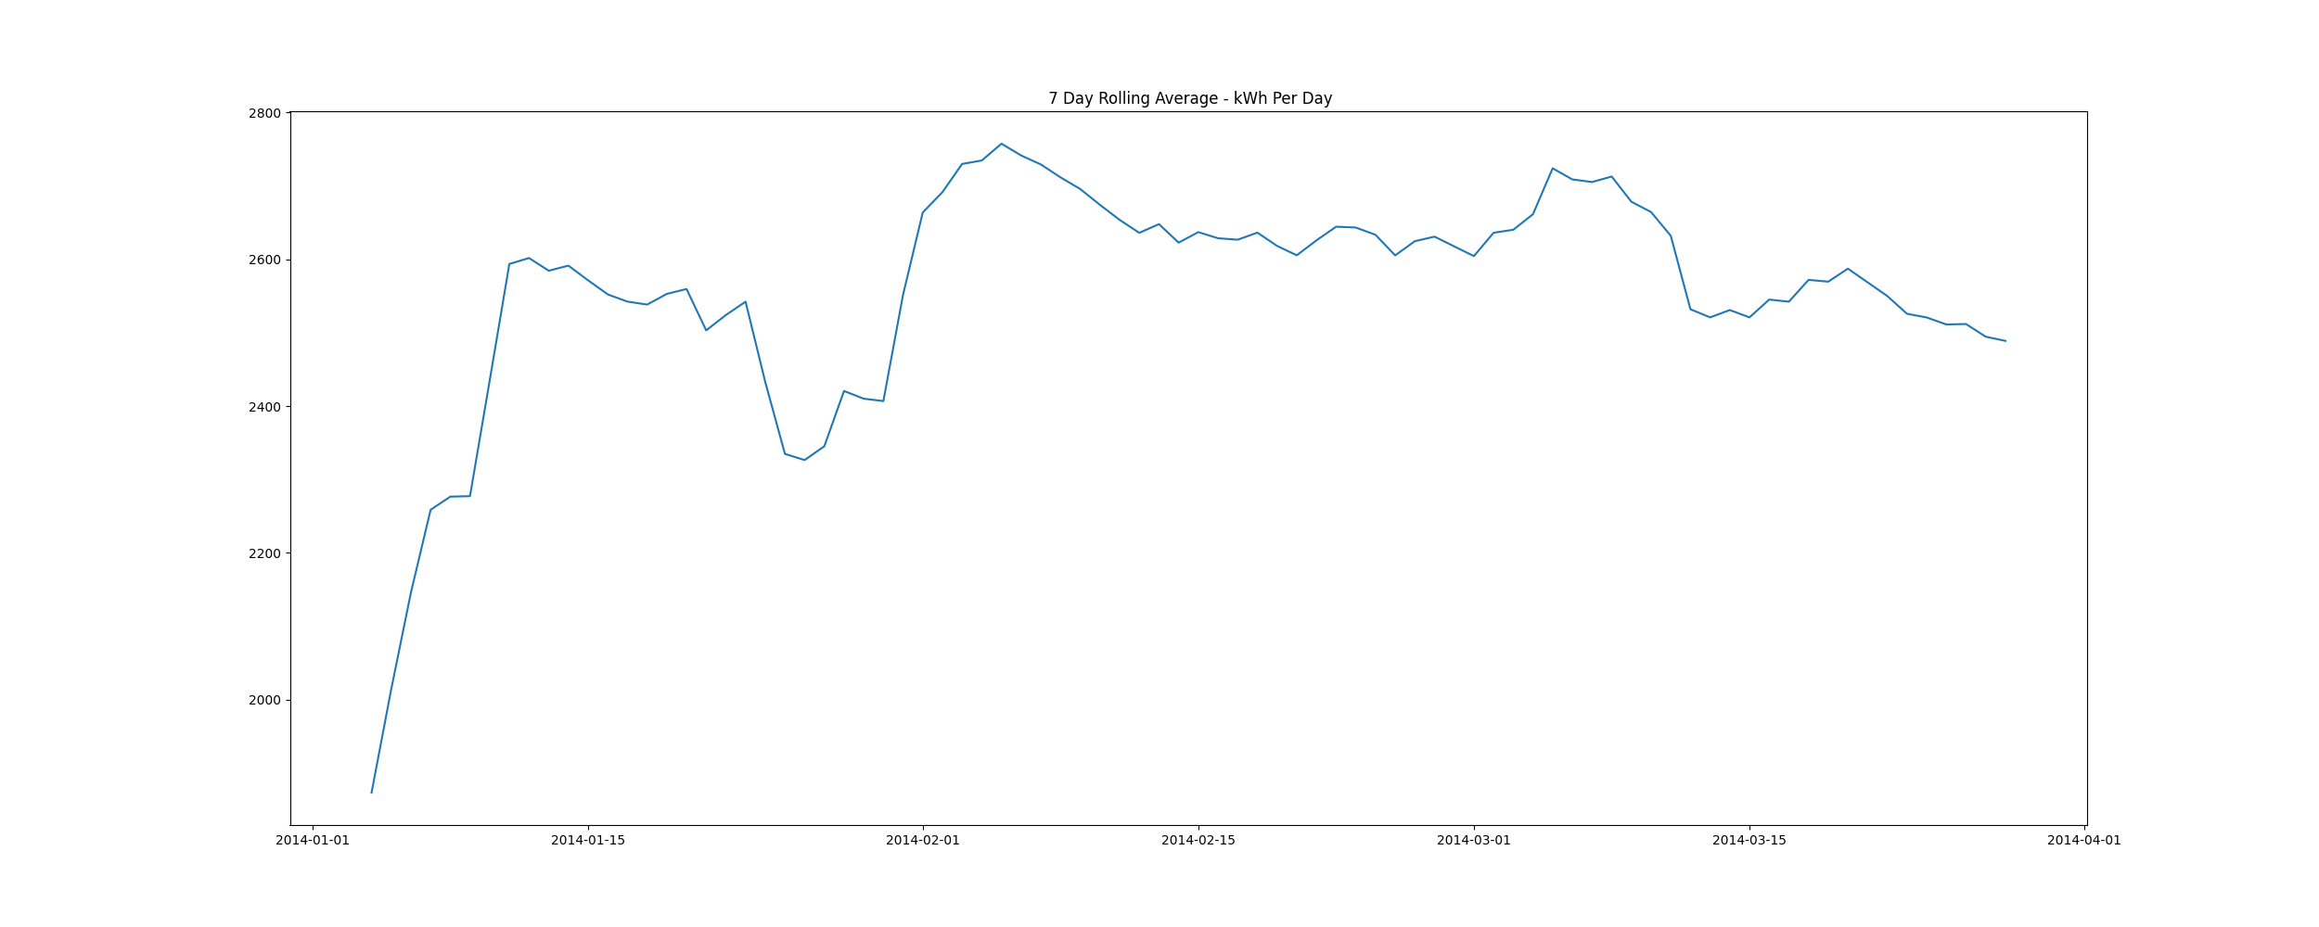

# Demand Plots By Month

Demands_for_Winter_Month_February.png

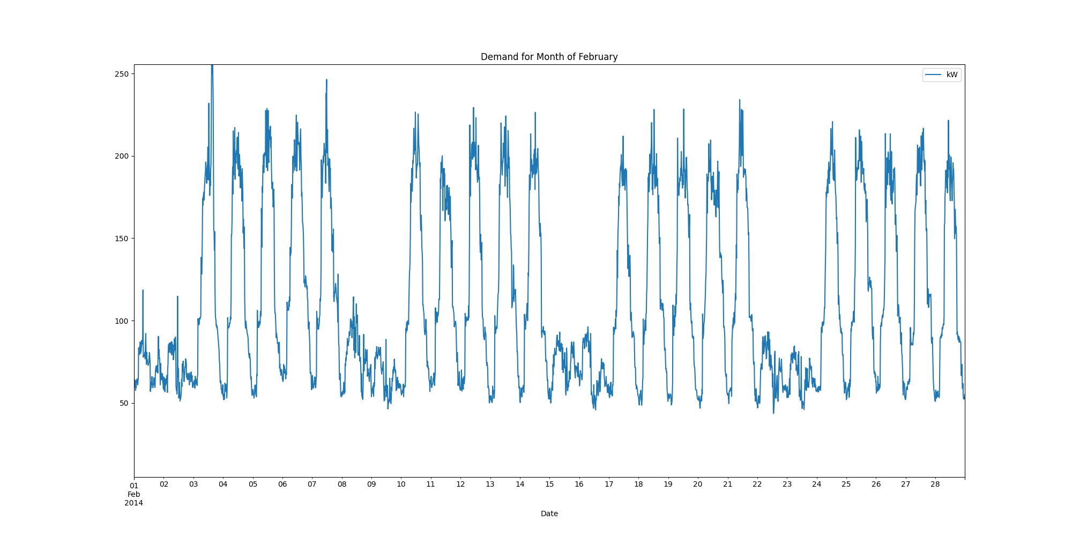

Demands_for_Winter_Month_January.png

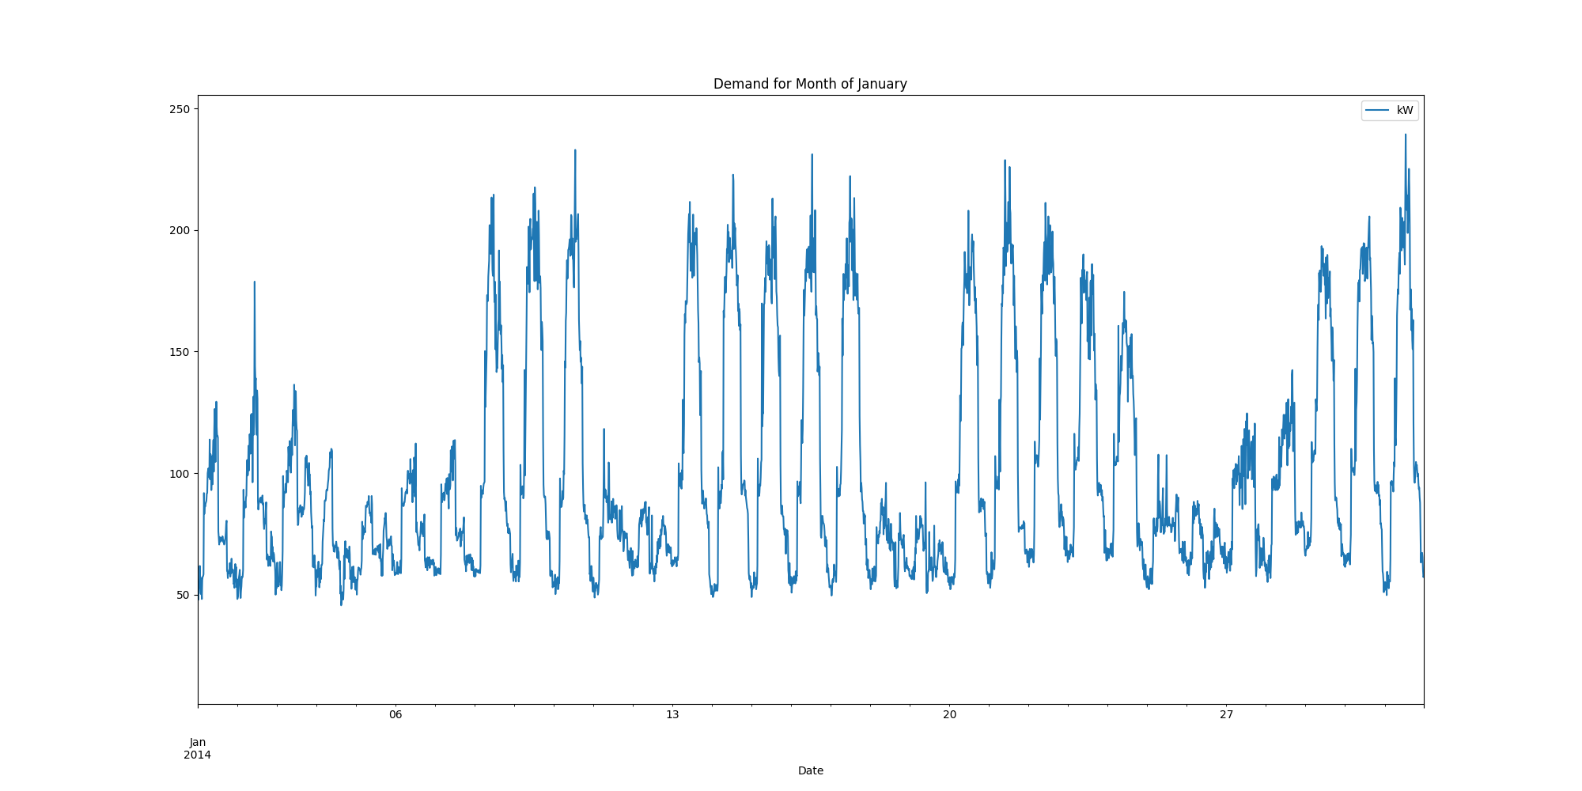

Demands_for_Winter_Month_March.png

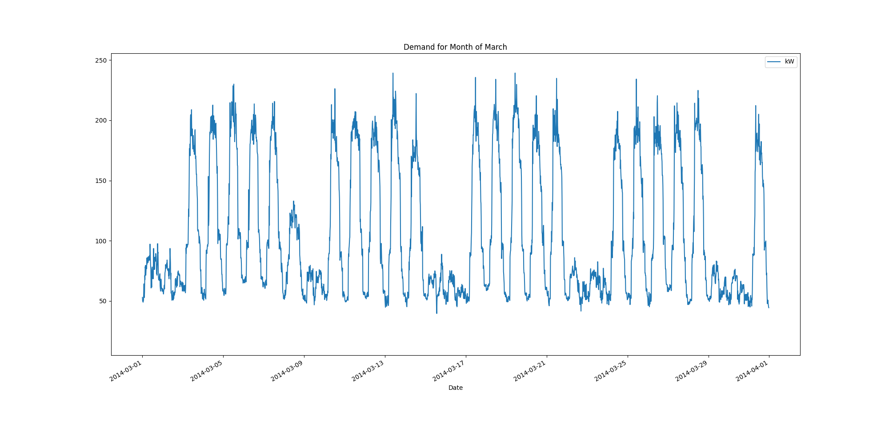

Data Analysis Report Summer

Summer Months Electrical Load Profiles

datasetPlot.png

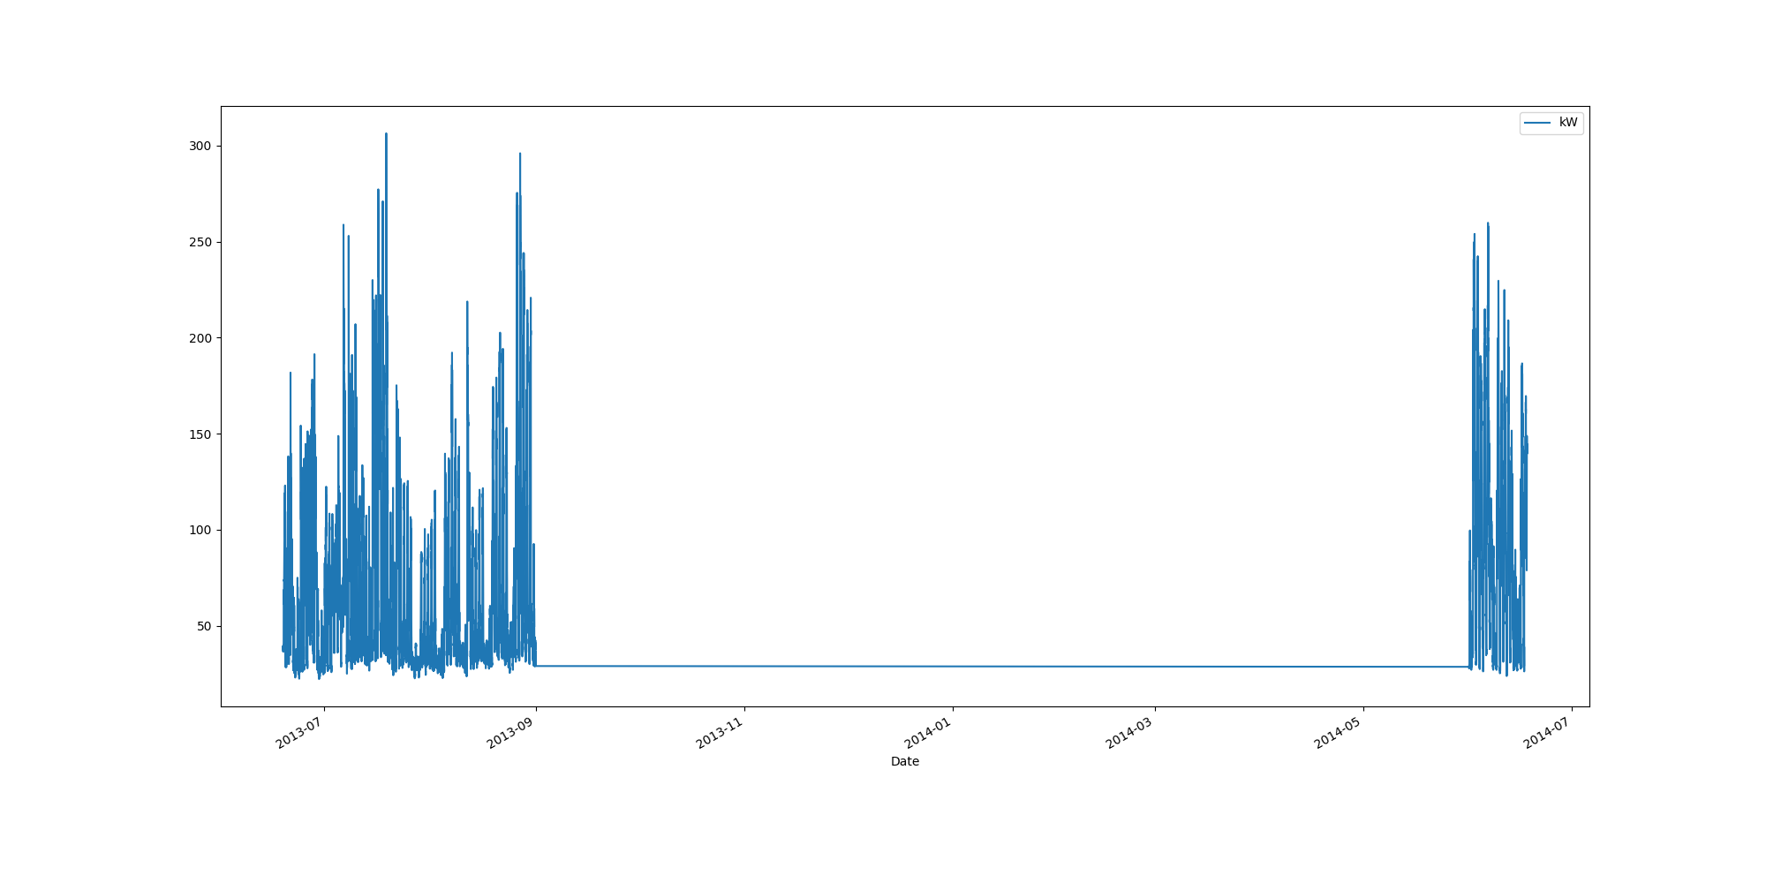

# Max Demand Found In Dataset

kW 306.4  
Name: 2013-07-19 05:15:00, dtype: float64

# Dataset Summary Statistics

kW  
count 8736.000000  
mean 71.822024  
std 50.853351  
min 22.200000  
25% 33.800000  
50% 48.400000  
75% 98.200000  
max 306.400000

# Highest Ranked Change Point Algorithm Detection

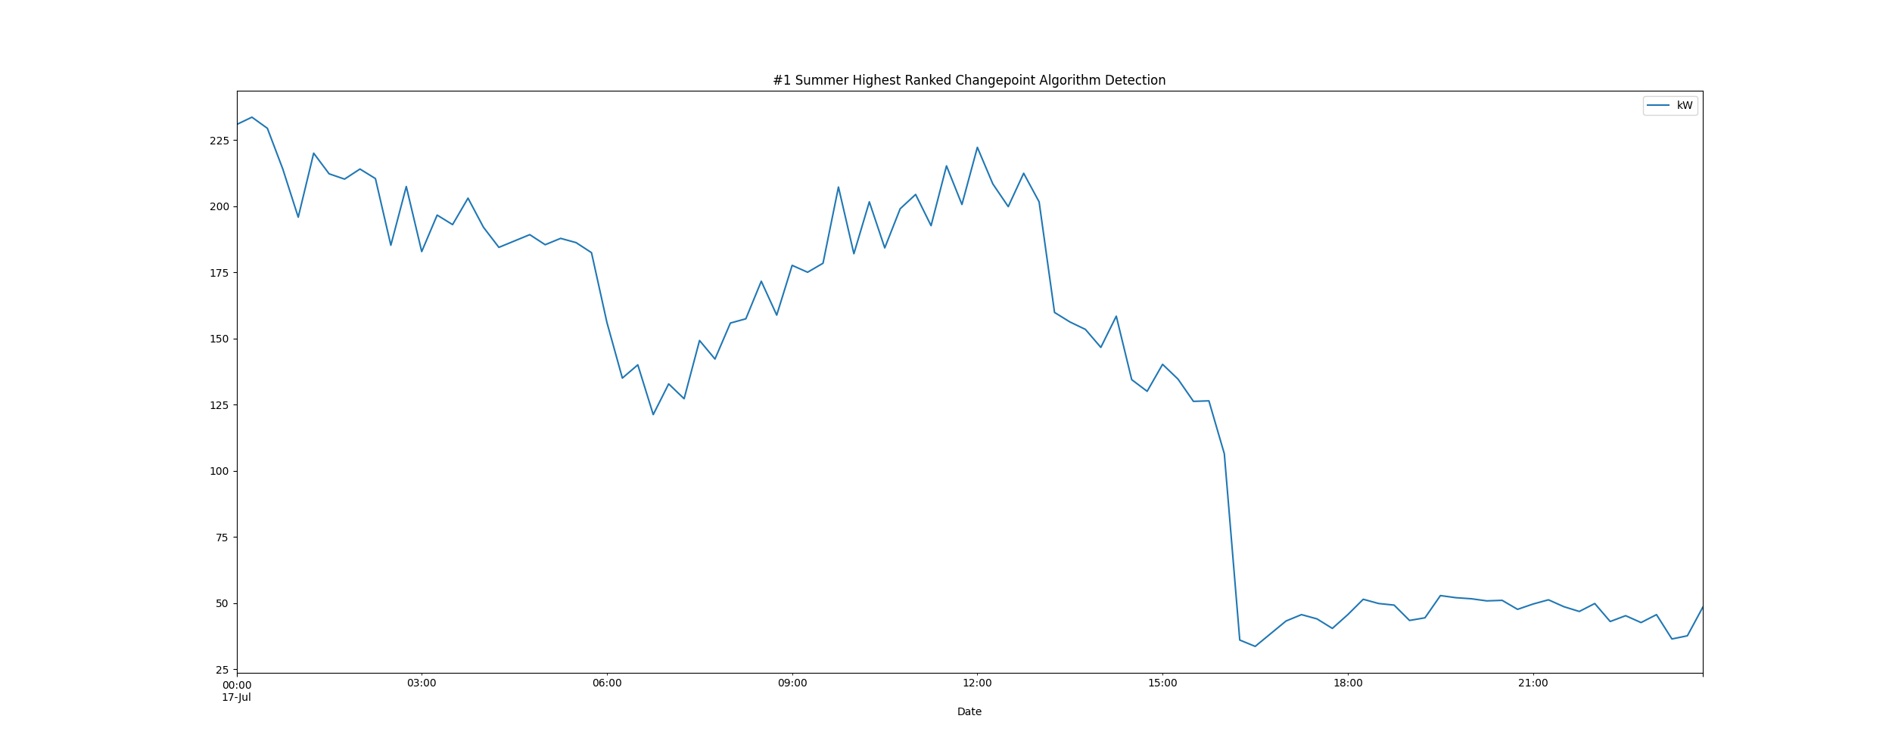

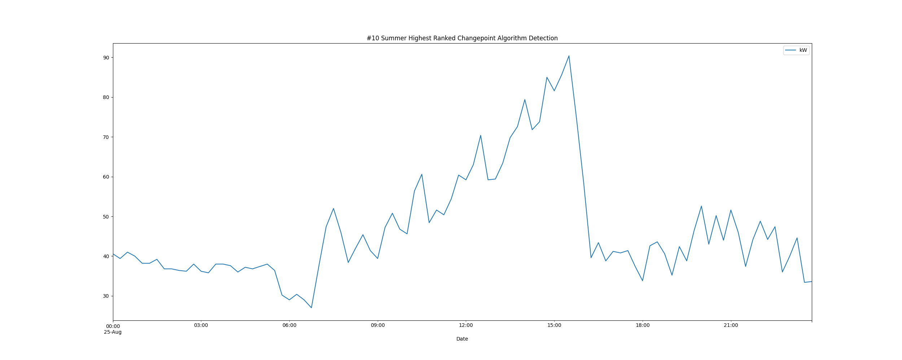

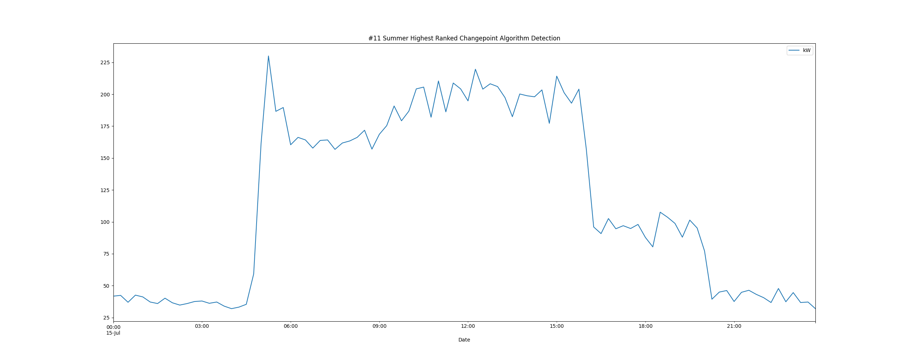

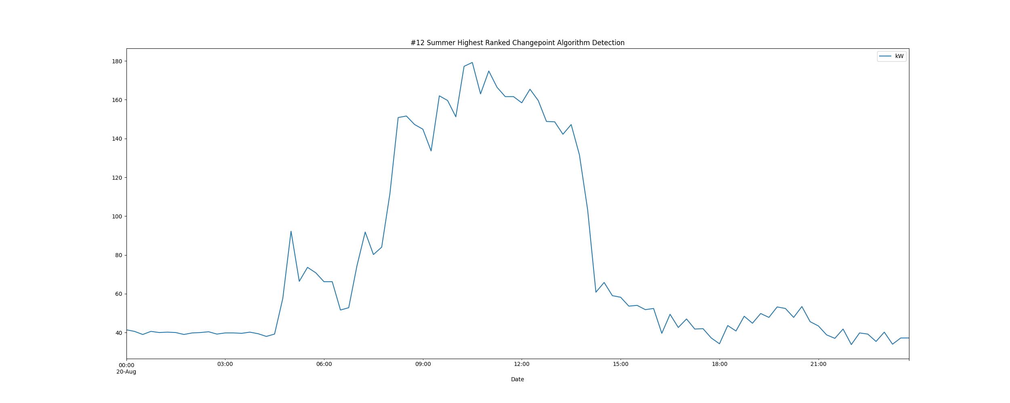

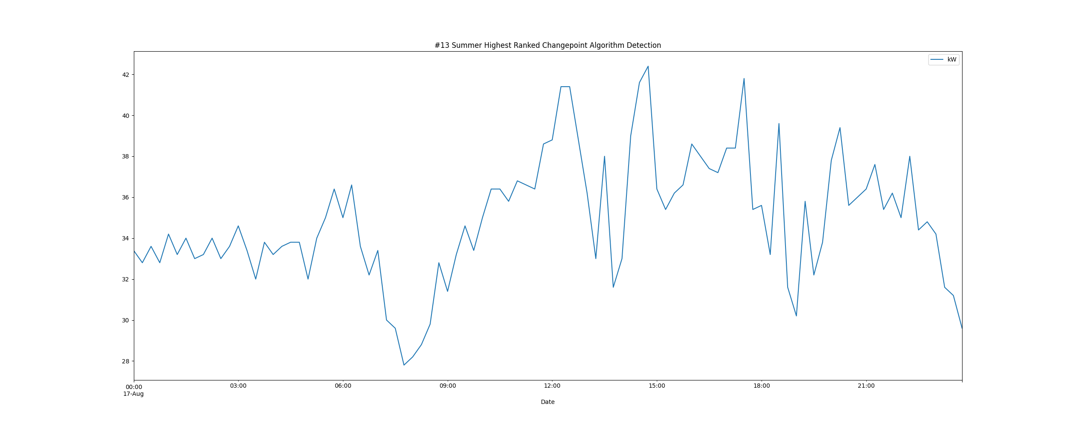

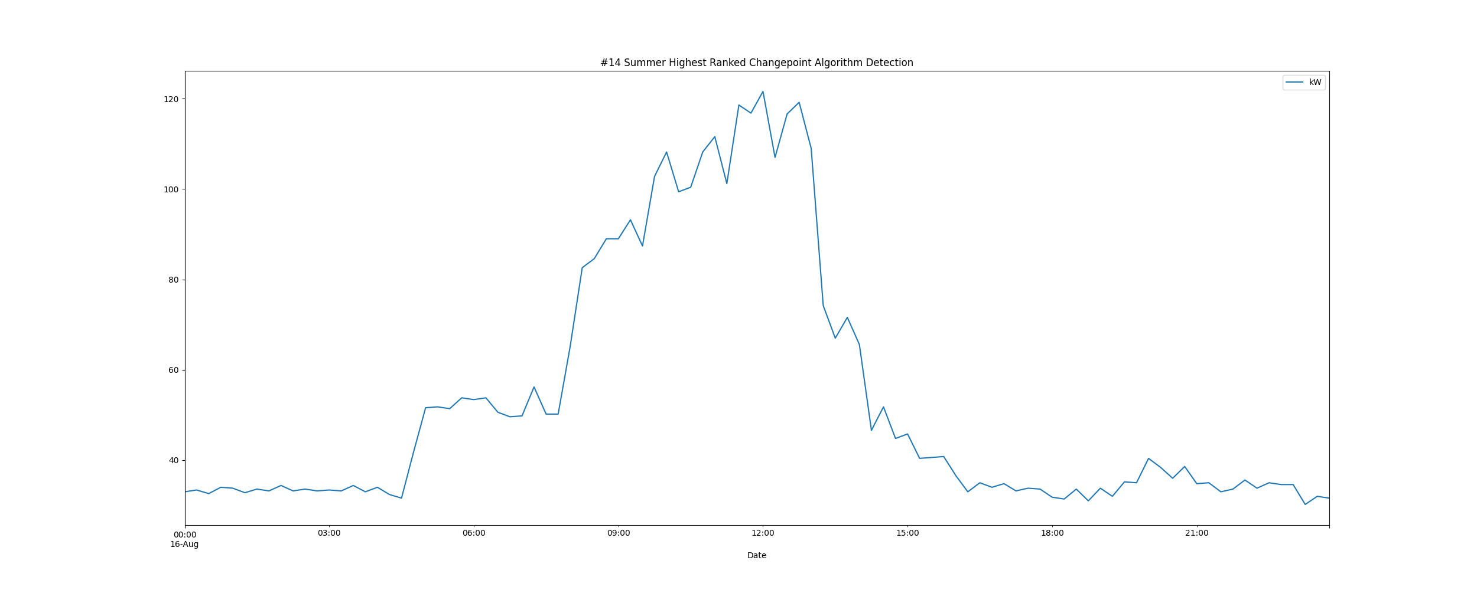

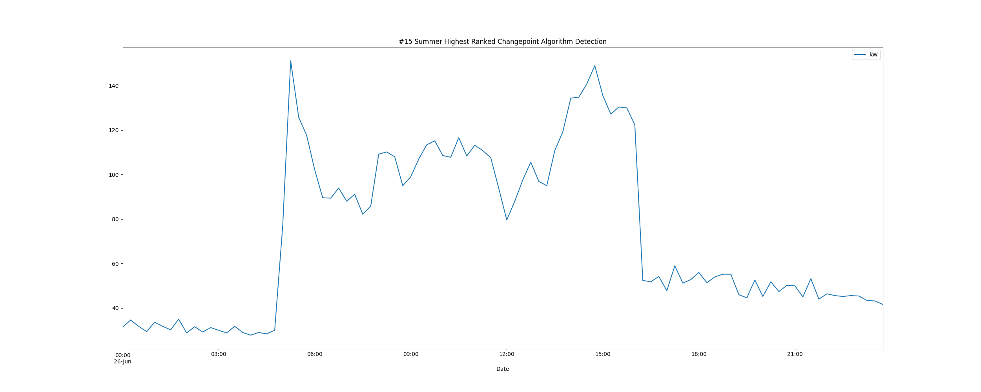

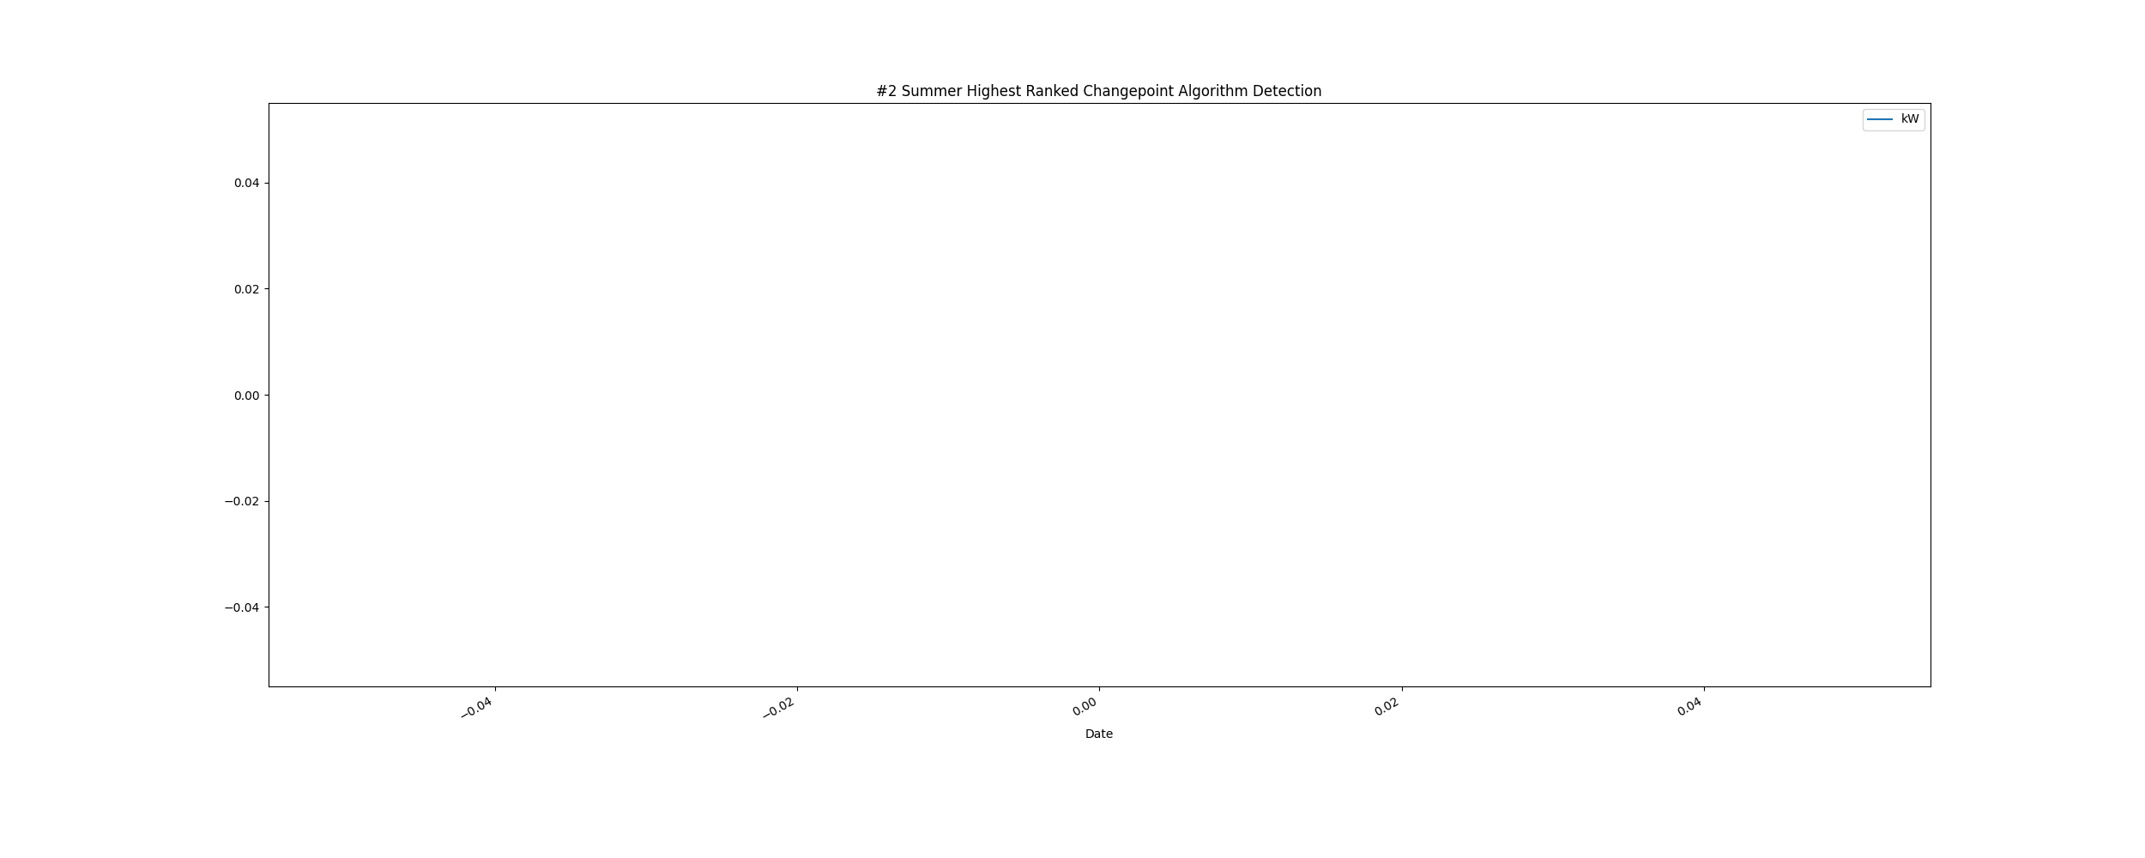

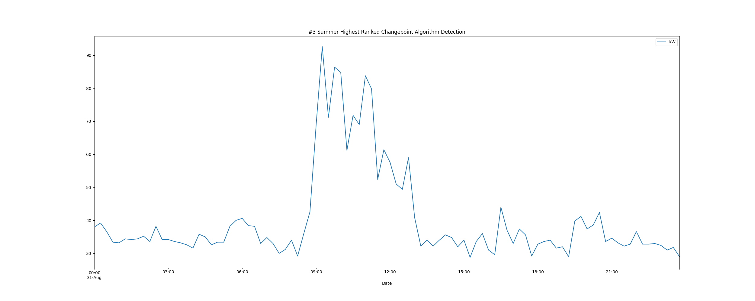

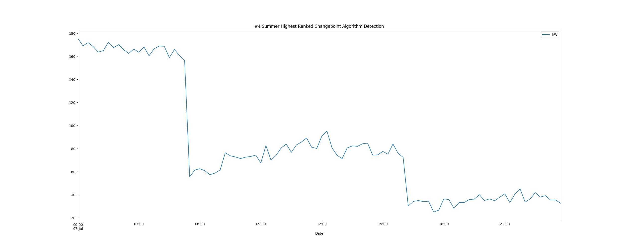

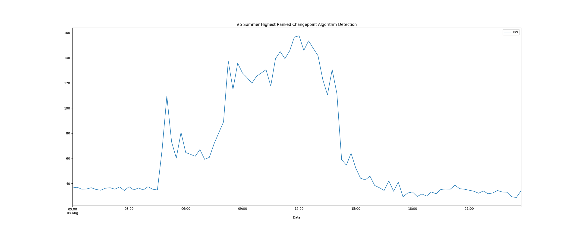

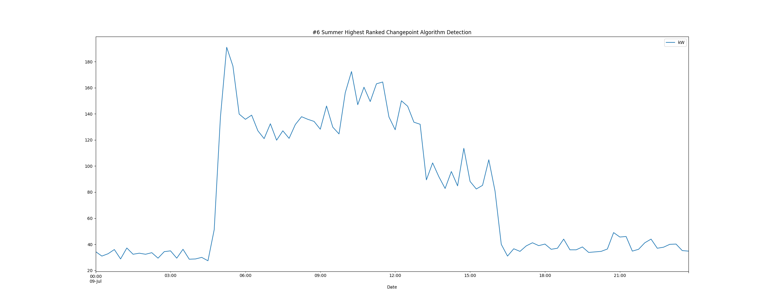

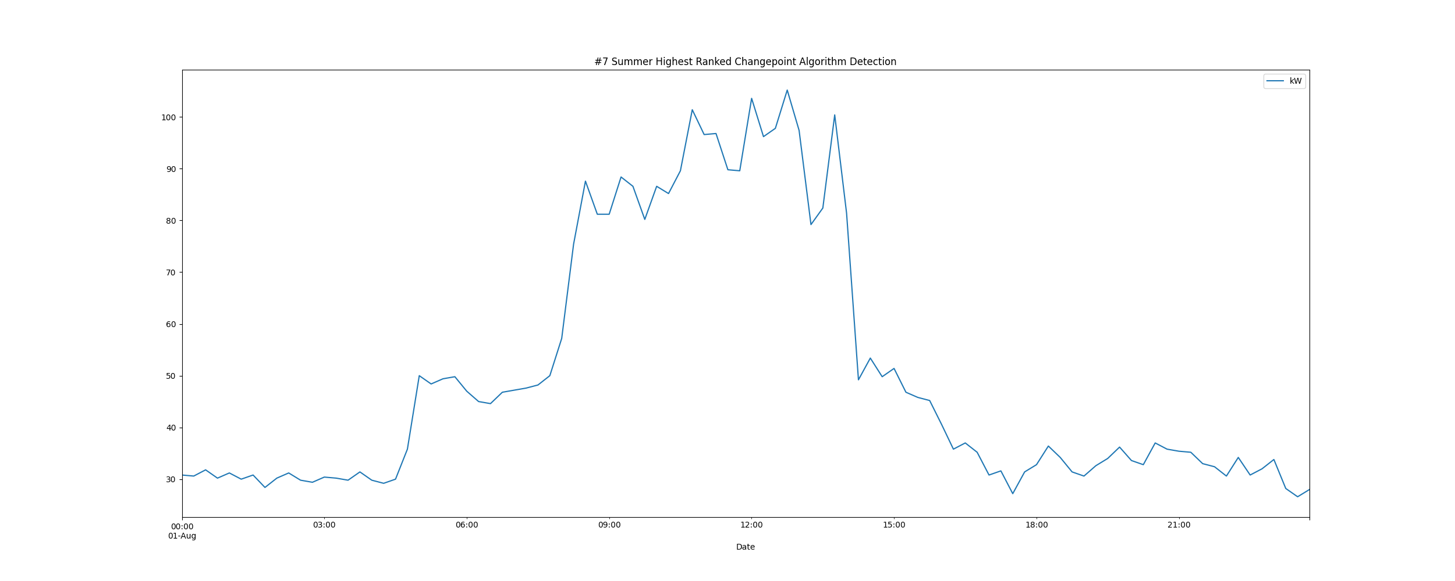

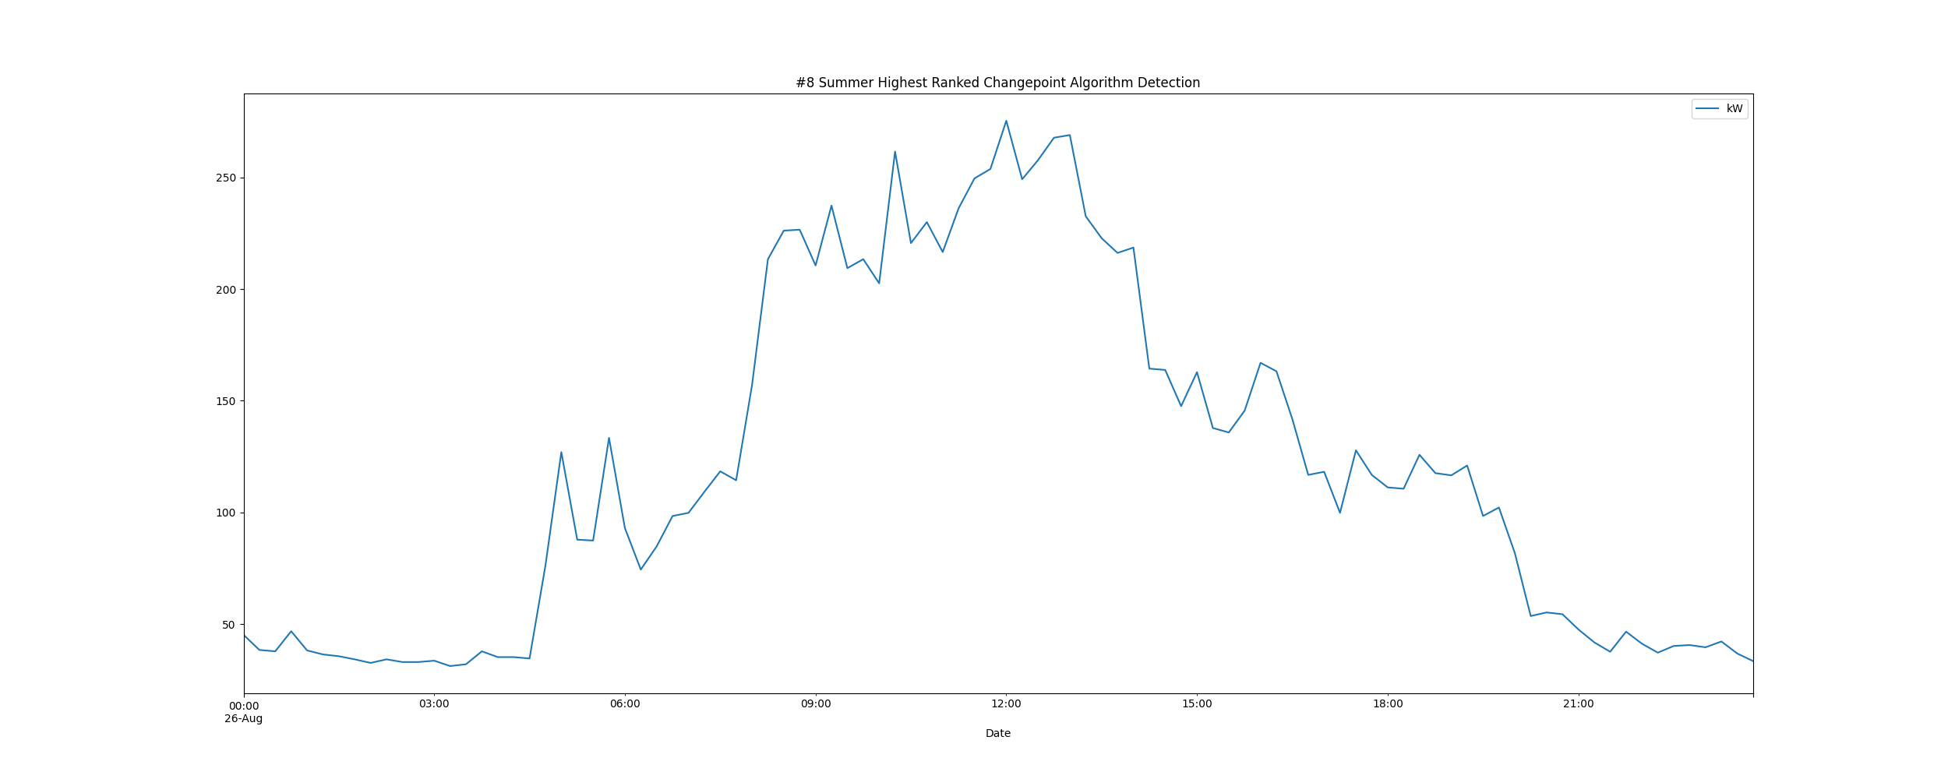

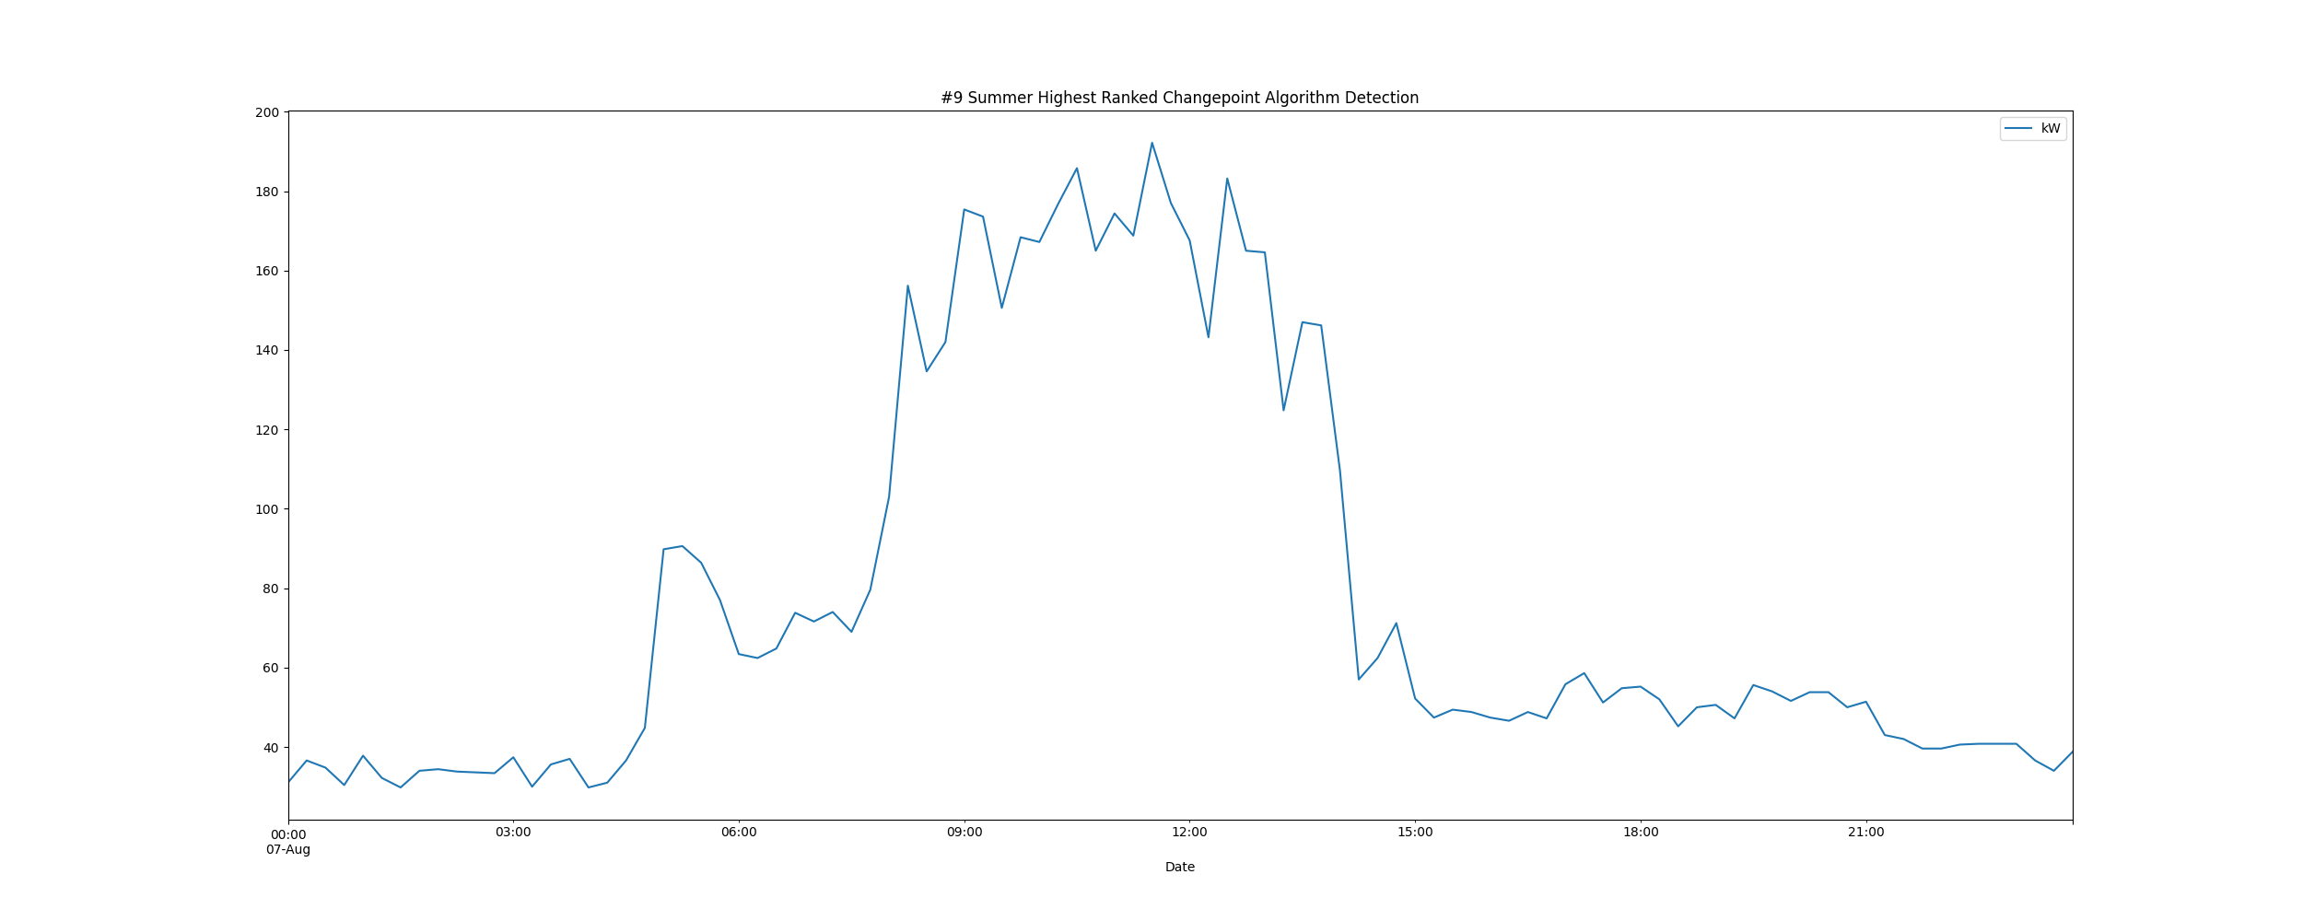

# Daily High and Low Load kW Values

highLowLoadsPlot.png

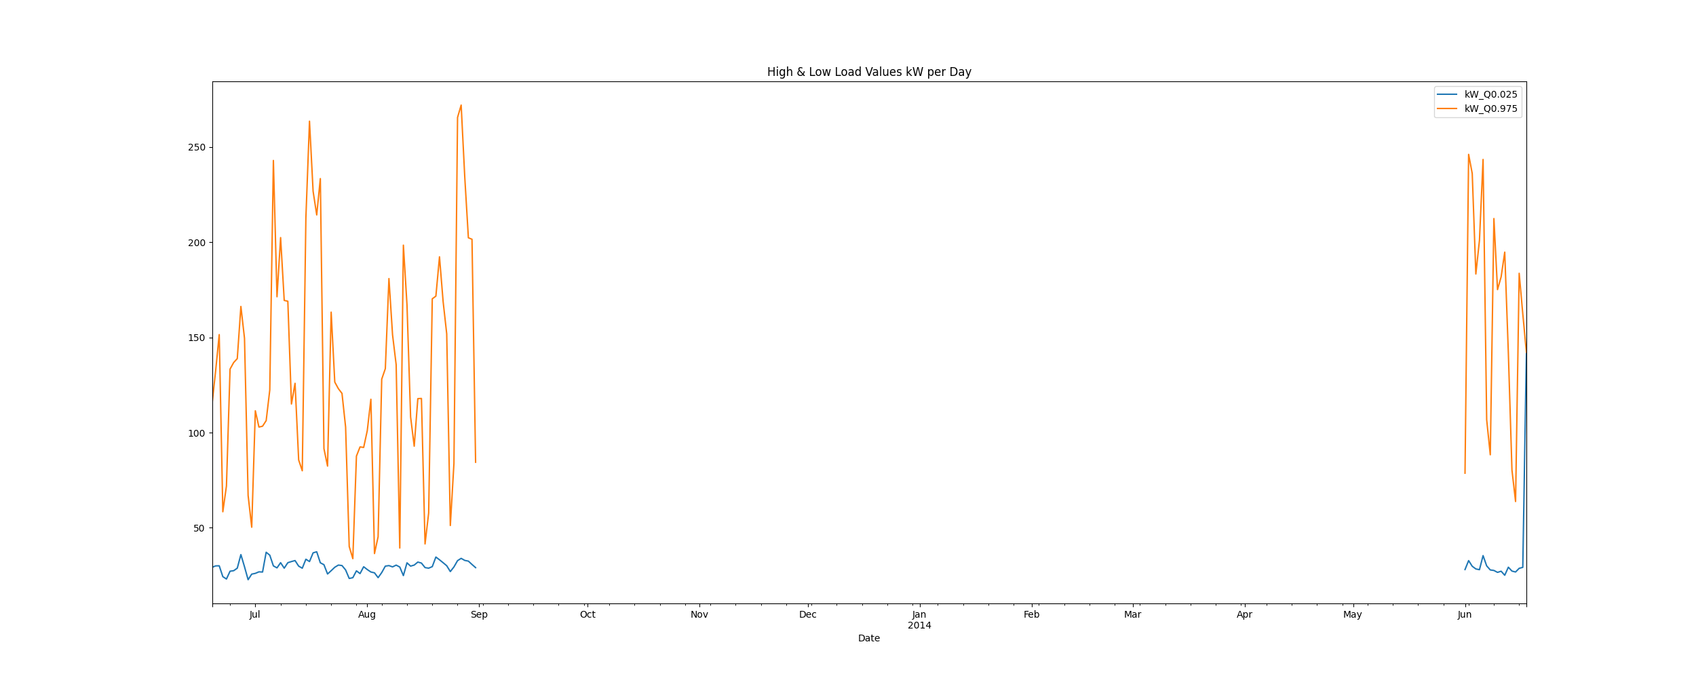

# Max Demand and Hour of Day Plot

Max_Demand_and_Max_Hour_of_Day.png

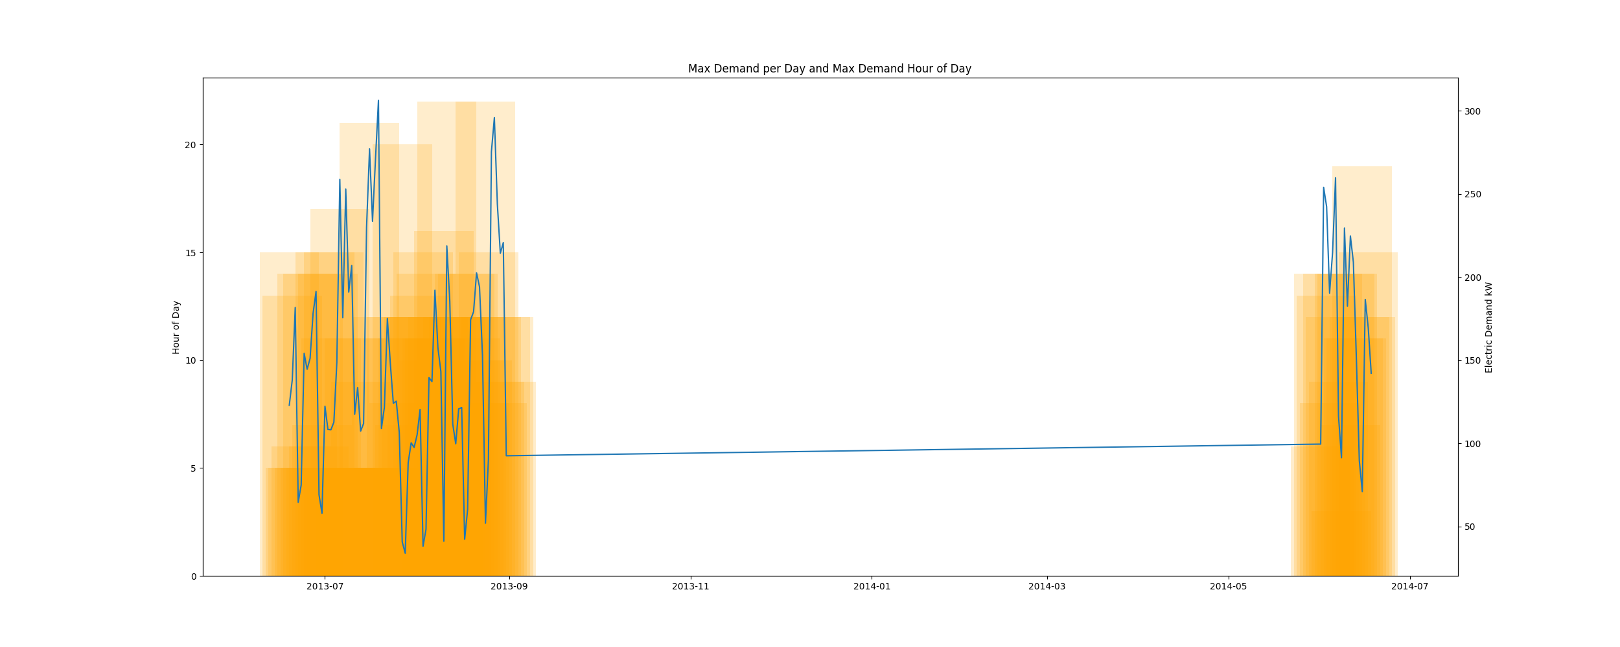

* Resampling the interval dataset to calculate units of energy KWh/day, the first day is 2013-06-19 and the last day is 2014-06-18
* Total days in dataset 364 days
* Total Sum of calculated electrical energy 156975.63333333333 kWh

# kWh Rolling 7 Day Avg

kWhRollingAvg.png

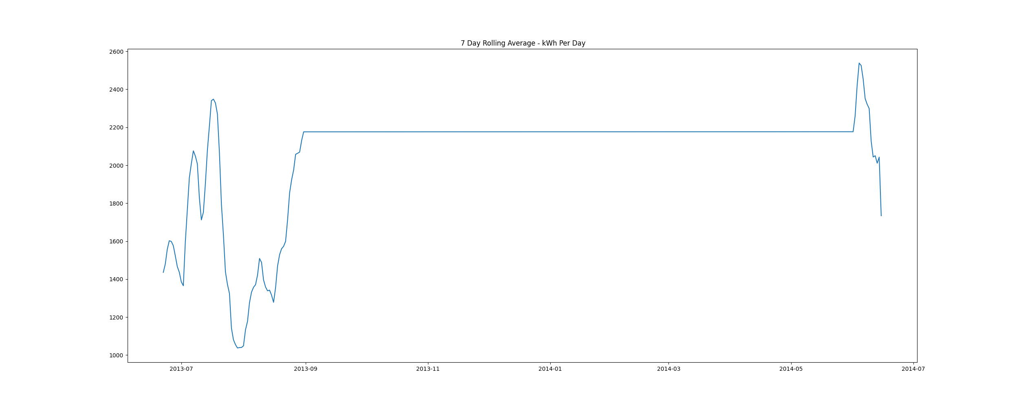

# Demand Plots By Month

Demands_for_Summer_Month_August.png

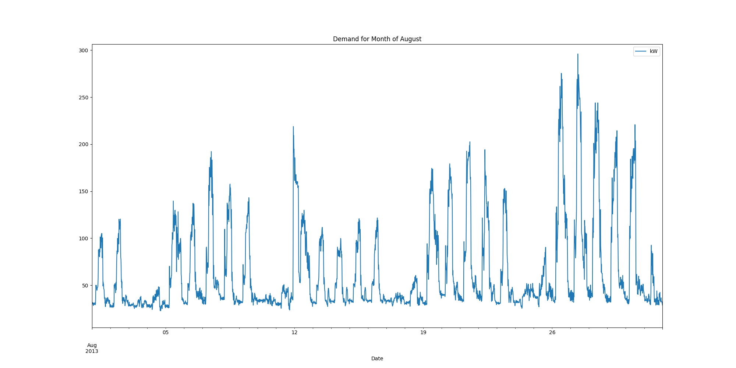

Demands_for_Summer_Month_July.png

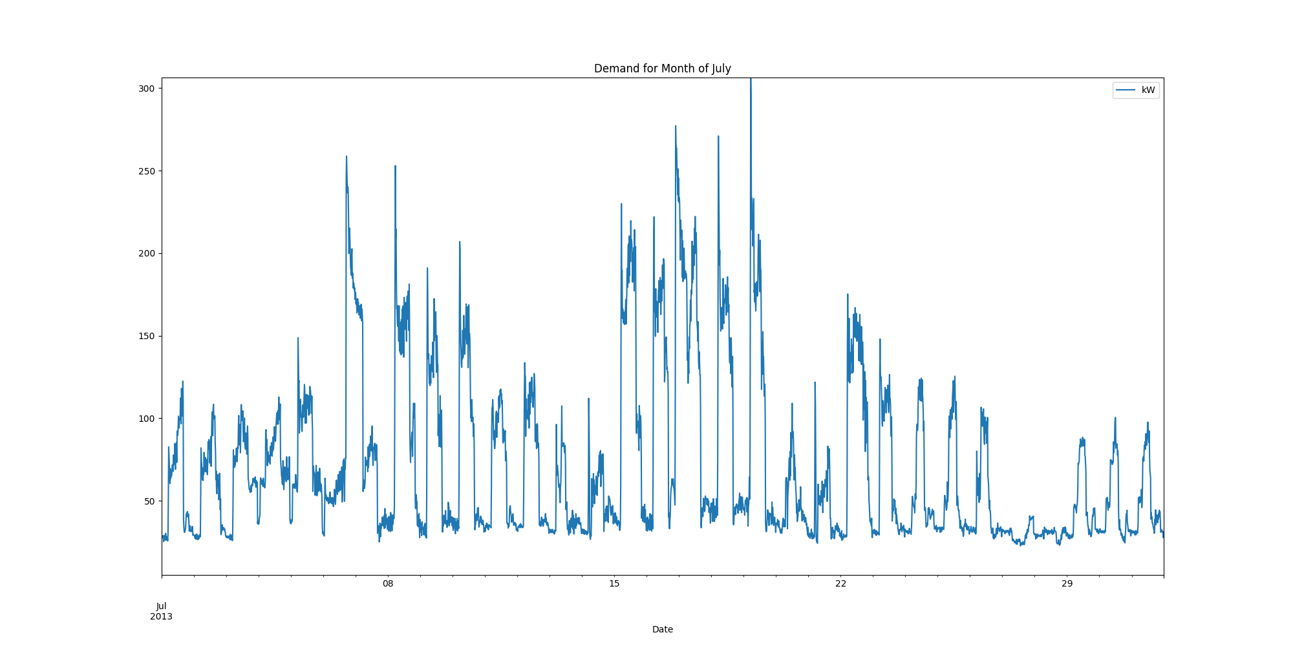

Demands_for_Summer_Month_June.png

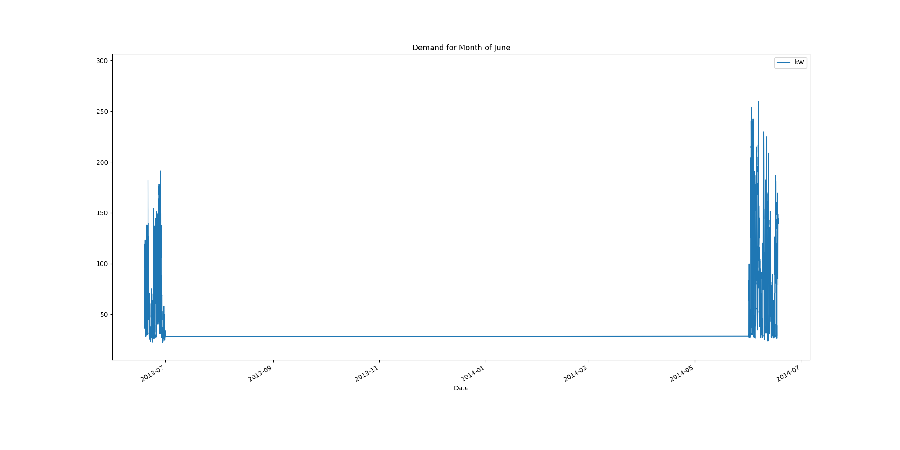

report compiled on:

01/02/2021 07:58:54